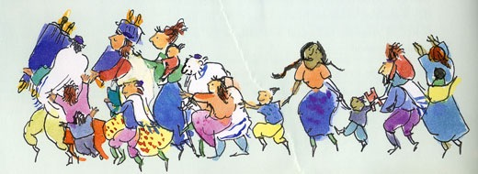

Dancing with the Torahs!
The Big Torah Twirl & Unfurl!

Sunday, September 30, 2018 Erev Simchat Torah

5:30 PM: Communal Festival Potluck Dinner
7:15 PM: Simchat Torah Service and Celebration for Ages 0-120
This year, we invite these special groups of Adat Shalomers and friends for Torah honors —
see if you fit into one (or more) of these groups and let us honor you!

1. Federal employees and contractors
2. Educators (at every level - for children and adults)
3. Parents of all kids 0-12
4. Parents of teens
5. All Torah, haftarah readers and shlichey tzibur
6. All non-profit board members
7. Everyone 70 and over

This year’s Chatan Torah–

Chatan/Kalat Breisheet: Kitah Zayin (7th Grade)

Join us for the final blast of seasonal joy as we unfurl the Torah and hear its ending and beginning.

Thursday, October 12, Simchat Torah/Shemini Atzeret

9:30 AM Festival Morning Service w/ Hallel, Hakafot & Yizkor
Led by Rabbi Fred & Hazzan Rachel

*For those who don’t yet know: this holiday, “the joy of Torah,” is the closing festival of the whole Days of Awe season. We celebrate the completion of a year of Torah reading and study and begin a new one with joyful melodies, dancing and special honors. In the evening, we’ll open the whole scroll (almost!) and take ourselves on a quick Torah text romp.

Visit www.adatshalom.net for more information.
