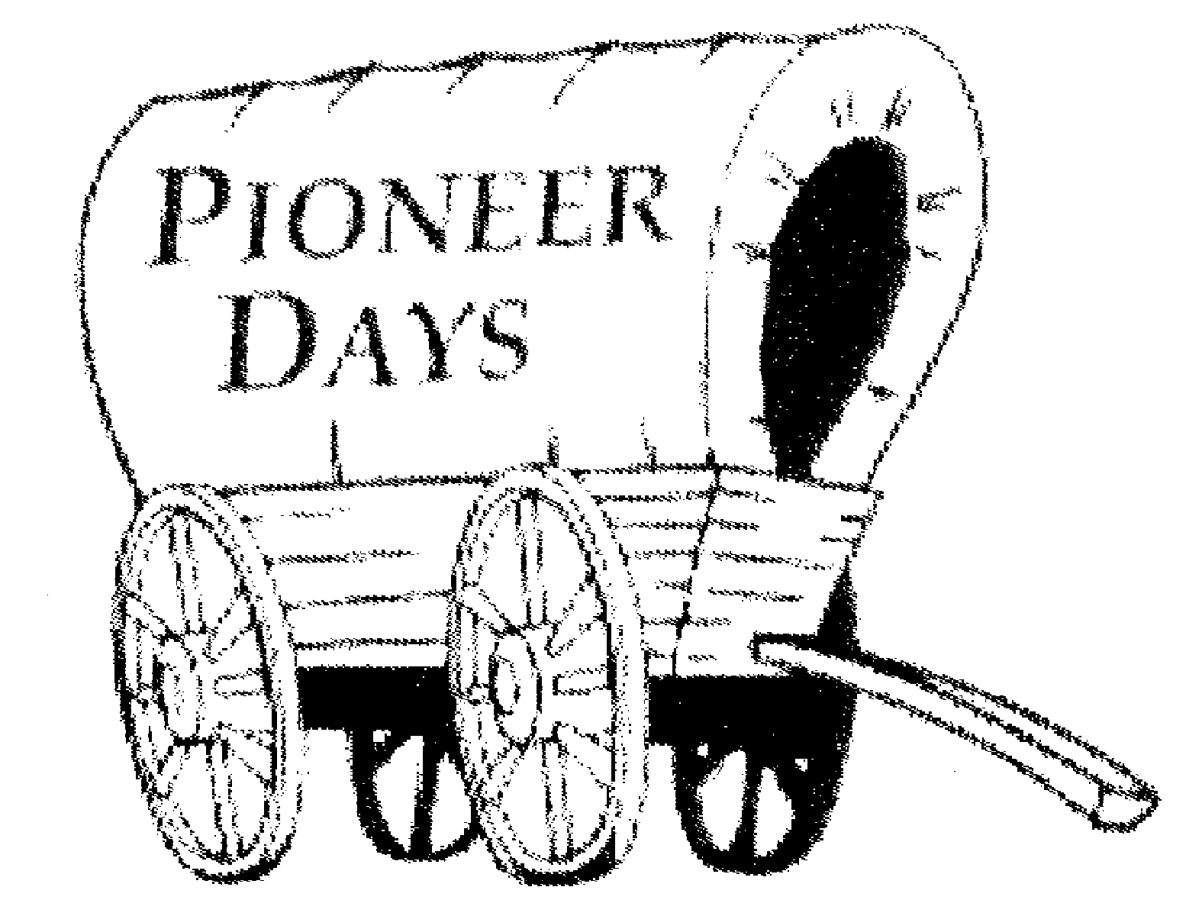
A SHORT HISTORY OF PIONEER DAYS

What we know as Pioneer Days began in 1937 with a community May Day affair. All school children participated. The grammar school furnished a rhythm band, and a queen and her court were chosen from the high school.

The hit of day was the comedy provided by a group of townsmen who dressed up as girls and clowned through a May dance of their own. Their May Pole was a crooked tree branch stuck in a nail keg with dangling carpet rags for streamers. That night a well-attended dance was held at the tennis courts. In all, the celebrations netted $28.

A rodeo on the next day included a boot race, package race, rescue race, potato race, relay race, musical chairs event, a take race, and a pony express race. A beef barbecue and ice cream capped the event, A soft drink concession was opened, and Twentynine Palms Produce furnished free coffee.

The following year the celebration was called Pioneer May Day, and in 1940 a parade was added. In 1941 the Chamber of Commerce took over the arrangements and changed the date to April. Rationing during World War II postponed further yearly events until 1946 when the celebration was once again held in May. In 1948 the Pioneer Day events moved permanently to October and Western days were adopted as the fixed theme.

Three-day celebrations started in 1950, and Pioneer Days that year featured an ever-increasing number of parade entries, booths, and exhibitions. As the town has more than tripled since the 1950s, Pioneer Day’s activities have grown with it’s population, increasing in scope and variety to become an annual event that both newcomers, as well as old-timers, look forward to with interest!

