Summer Camp
Ages 3 (potty trained) to entering First Grade in the fall
Monday through Friday 8:00 am to 1:00 pm and Optional Extended Care
Space is limited to 16 children per camp

Choose one or more weeks:

Date of Camp Theme
June 19-23 In the Summer Garden with Ms. Veronica & Ms. Christl
June 26-30 A World of Watery Wonder with Ms. Veronica & Ms. Christl
July 31-August 4 Row, Row, Row Your Boat with Ms. Inge
August 7-August 11 Ladybugs, Butterflies, Beetles and Bees with Ms. Inge

Fees: $180 Camp only
$230 Camp plus Extended Care from 1 pm to 3 pm
$255 Camp plus Extended Care from 1 pm to 5 pm

Our summer camp is lovingly provided by our Early Childhood Faculty and Extended Care Staff. If you are new to Cedar Springs, summer camp is a great way to introduce your child to the rhythm and joy of a Waldorf classroom. Camp includes daily activities such as singing, movement, storytelling, crafts, gardening, and water play. A wholesome snack is included in the morning and children bring their own picnic lunch.

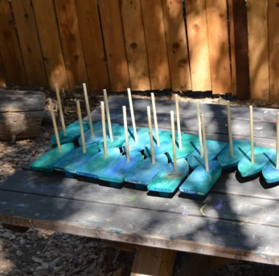
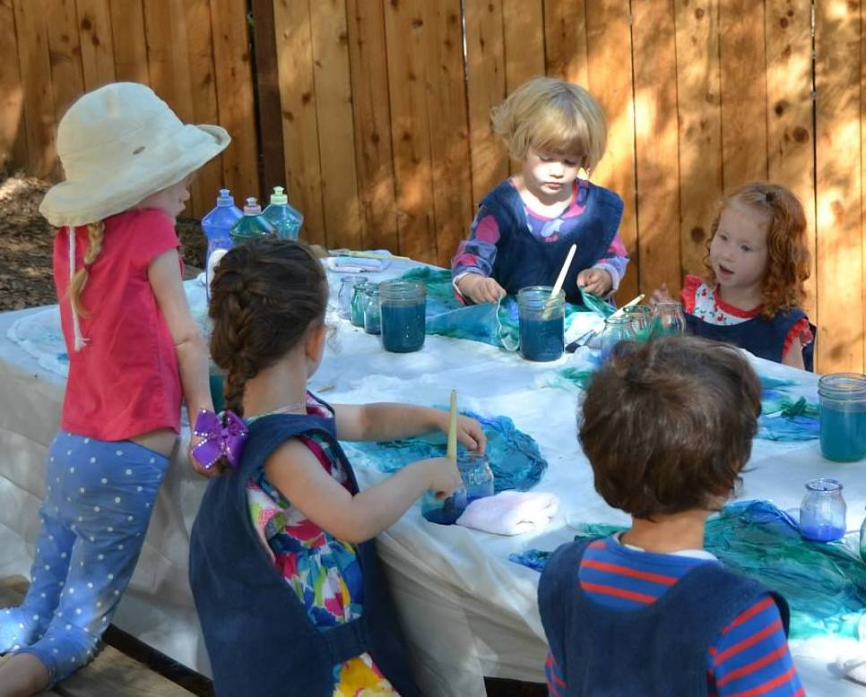
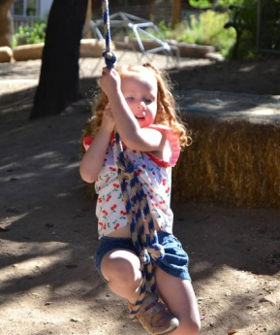

Singing and Movement
Storytelling
Crafts and Gardening
Water Play
Nature Walks

Registration forms and payment available online at www.CedarSpringsWaldorf.org

For additional information, please contact Monica Ness by email: Enrollment@CedarSpringsWaldorf.org
Cedar Springs Waldorf School   (530) 642-9903  6029 Gold Meadows Road, Placerville, CA 95667

