***Version: 11/09/15***

|  |  |  |  |  |  |  |  |  |  |
| --- | --- | --- | --- | --- | --- | --- | --- | --- | --- |
|  | |  | |  | |  | |  | |
|  | |  | |  | |  | |  | |
|  | **ADULT** | **MAROON** | | **ASH/GREY** | |  | |  | |
|  | **SIZES** | **$10 (S-XL)**  **2X $11 3X $12** | | **$10 (S-XL)**  **2X $11 3X $12** | |  | |  | |
|  | Small ($10) |  | |  | |  | |  | |
|  | Medium ($10) |  | |  | |  | |  | |
|  | Large ($10) |  | |  | |  | |  | |
|  | XL ($10), 2X ($11), 3X ($12) (special order) | XL 2X 3X | | XL 2X 3X | |  | | *T-Shirt Sub-total* | |
|  | **TOTAL T-Shirts** |  | |  | |  | | $ | |
|  |  | |  | |  | |  | |
| **HOODIES** | |  | |  | |  | |  | |
|  | **ADULT SIZES** | **MAROON ZIP Embroidered Hoodie**  **$20 (S-XL)** | |  | |  | |  | |
|  |  | **2X $21 3X $22** | |  | |  | |  | |
|  | Small | Sold out | |  | |  | |  | |
|  | Medium | Sold out | |  | |  | |  | |
|  | Large | Sold out | |  | |  | |  | |
|  | XL $20, 2X ($21), 3X ($22) | XL 2X 3X | |  | |  | | *Hoodie Sub-total* | |
|  | **TOTAL Hoodies** |  | |  | |  | | $ | |
|  |  |  | |  | |  | |  | |
|  |  |  | |  | | ***TOTAL Enclosed, cash or check*** *#_______* | | $ | |
| **STUDENT NAME ___________________________________ HR Teacher _________________ Grade ____** | | | | | | | | | |
| **Parent Contact Email _______________________________ Parent Phone #: ______________________** | | | | | | | | | |
|  | ***Please make checks payable to Gamble Rogers PTO. Thank you. Orders will be delivered to homeroom.***  ***\*DELIVERY NOTES:*** *In-Stock items delivered to homeroom within 3-5 school days. Custom-embroidered zip hoodies will be delivered 14-18 school days from the order date* ***with the embroiderer****. Some delays are possible, depending on weekends and holidays. Thank you for your order, patience and understanding.* | | | | | | | | |
|  |  | | | | | | | | |

**GRMS SPIRIT WEAR**

**ORDER FORM**

*Perfect for Spirit Fridays and suitable for PE!*

2015-16

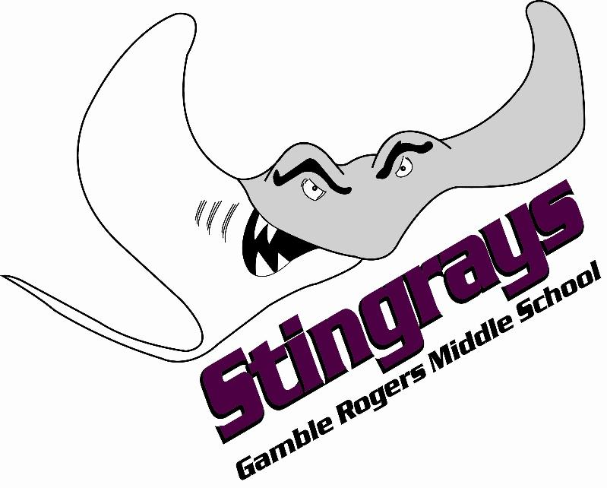

**PTO**