Gamble Rogers Tennis Team Tryouts
February 6 @ 4:30 pm
February 7 @ 4:30 pm
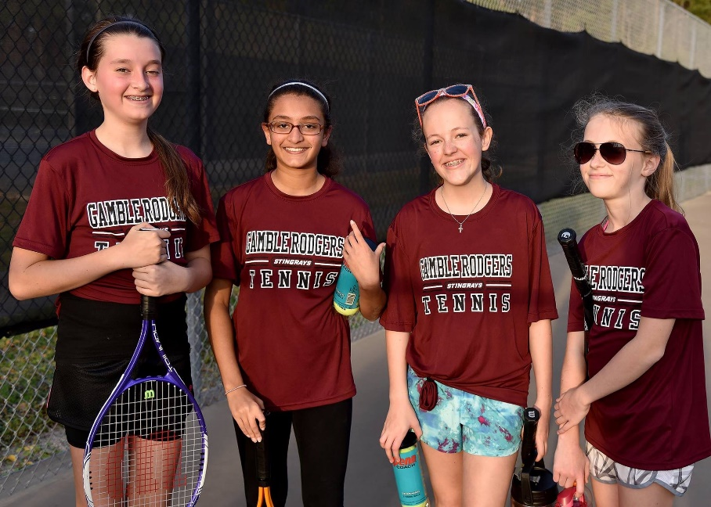
This may be your child’s last chance to learn how to play a lifetime sport.
Getting children into tennis at a young age helps them develop physically, mentally & socially. It is an “individual” sport where kids can improve their self-esteem, confidence, focus & problem solving skills. Kids will learn that succeeding is really more about how they play the game than winning or losing.
Treaty Park will be the home court for Gamble Rogers. The team will again be coached by PTR Certified Professional “Coach Vita” & Director of Tennis at Treaty Park & USPTA Certified Professional “Coach Bobby”.
Practices will be on Wednesdays at 4:30 pm and matches on Fridays at 4:30 pm.
New SJMSAA Registration Requirement: this year players are required to register and pay prior to tryouts. If a child does not make the team, their registration fee will be refunded. Students register at www.sjmsaa.com/tennis.
For information tennis clinics & lessons at Treaty Park, do not hesitate to contact Coach Bobby at staugustinetennis@comcast.net.

