Community Shred
9am to Noon
Saturday, April 21

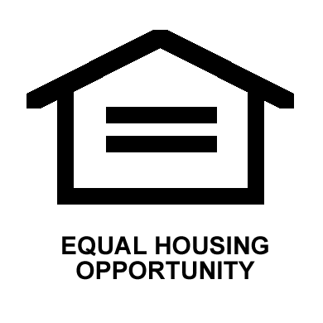
200 E Frontage Rd
Waconia, MN 55387
952-442-2141
No Charge for Shredding
Open to Everyone!
