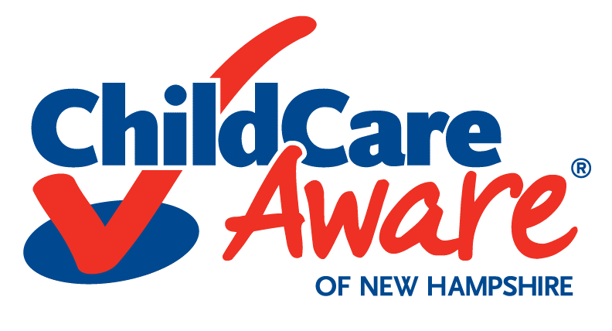
Child Care Resource & Referral
Program Information Condensed Update Form

Please take a few moments to complete this form. In order to better serve both providers and families, we need to have up to date and complete information on your programs. We are requesting that programs submit a copy of their program license so that we can ensure that we have the most accurate information. Please feel free to add any comments or explanations. Please remember that you may change any information that we have in our database at any time with just a phone call or an email. We would also appreciate your feedback on our program.

If you have any additional comments in regards to our program please contact us at 1-855-393-1731. Comments may also be sent via email to ccrr@snhs.org.

*Mail completed form and a copy of your Program License to
Child Care Aware of NH, Attn: Karen Abbott
88 Temple Street, Nashua, NH 03060. Thank you!

Program Information
Director or Site Director/Provider Name: Click here to enter text.
Business Name: Click here to enter text.
Location:
Street: Click here to enter text. Unit # Click here to enter text.
City: Click here to enter text. State: Choose an item.
Zip Code: Click here to enter text. County: Click here to enter text.
Mailing address if different from above:
Street: Click here to enter text. Unit # Click here to enter text.
City: Click here to enter text. State: Choose an item.
Zip Code: Click here to enter text. + Four Zip Code Click here to enter text.
Contact Information:
Primary Phone: Click here to enter text. Ext.: Click here to enter text.
Fax: Click here to enter text.

PLEASE NOTE: Currently our newsletter, training calendar, “Monthly Minutes” and “At-A-Glance” editions are sent out via email. To disseminate this information we will be using the email address you provide below. Thank you in advance for helping us to reduce costs and minimize our carbon footprint. If you do not have internet access or an email account and need a hard copy please contact our office.

Email: Click here to enter text.
Program Website: Click here to enter text.
Vacancy Information:
Total Vacancies: Click here to enter text. As of what date? Click here to enter a date.

Vacancies: (Check all age groups that have vacancies.)

☐Evening ☐Full Time ☐Infant
☐Infant & Toddler ☐Kindergarten ☐Overnight
☐Part Time ☐Preschool ☐School Age
☐Toddler ☐Weekend

Rates: (For informational and statistical purposes only.)
Age Group: | Age Range | Hourly Rate: |  | Daily Rate: |  | Weekly Rate: |  | Monthly Rate
 |  | P/T F/T |  | P/T F/T |  | P/T F/T |  | P/T F/T
Infant 1 | 0-36 weeks | Click here to enter text. | Click here to enter text. | Click here to enter text. | Click here to enter text. | Click here to enter text. | Click here to enter text. | Click here to enter text. | Click here to enter text.
Infant 2 | 37 – 52 weeks | Click here to enter text. | Click here to enter text. | Click here to enter text. | Click here to enter text. | Click here to enter text. | Click here to enter text. | Click here to enter text. | Click here to enter text.
Toddler 1 | 1-2 years | Click here to enter text. | Click here to enter text. | Click here to enter text. | Click here to enter text. | Click here to enter text. | Click here to enter text. | Click here to enter text. | Click here to enter text.
Toddler 2 | 2-3 years | Click here to enter text. | Click here to enter text. | Click here to enter text. | Click here to enter text. | Click here to enter text. | Click here to enter text. | Click here to enter text. | Click here to enter text.
Preschool 1 | 3-4 years | Click here to enter text. | Click here to enter text. | Click here to enter text. | Click here to enter text. | Click here to enter text. | Click here to enter text. | Click here to enter text. | Click here to enter text.
Preschool 2 | 4-5 years | Click here to enter text. | Click here to enter text. | Click here to enter text. | Click here to enter text. | Click here to enter text. | Click here to enter text. | Click here to enter text. | Click here to enter text.
School Age 1 | 5-6 years | Click here to enter text. | Click here to enter text. | Click here to enter text. | Click here to enter text. | Click here to enter text. | Click here to enter text. | Click here to enter text. | Click here to enter text.
School Age 2 | 6-15 years | Click here to enter text. | Click here to enter text. | Click here to enter text. | Click here to enter text. | Click here to enter text. | Click here to enter text. | Click here to enter text. | Click here to enter text.

Technological Access
These questions pertain to how you and your program accesses technology.
Do you have a computer onsite that staff have access to? ☐Yes ☐No
Do you have Wi-Fi available onsite for staff use? ☐Yes ☐No
When accessing training information electronically what type of device do you use? (Select all that apply):
☐Computer ☐Tablet/iPad ☐Smart Phone ☐Other
☐Do not have ability to access electronically

IS THERE ANY OTHER SPECIAL INFORMATION ABOUT YOUR PROGRAM THAT YOU WOULD LIKE CHILD CARE RESOURCE & REFERRAL TO KNOW AND/OR SHARE WITH FAMILIES?

Signature of Person Filling Out This Form: Click here to enter text.
Title: Click here to enter text. Date: Click here to enter a date.
☐I do not want my program listed for referrals on www.nhchildcareaware.org Click here to enter text.

Thanks! And thank you for all that you do for NH Children and their Families!!!
Child Care Resource and Referral is a program of Southern New Hampshire Services. This service is offered under an Agreement with the State of New Hampshire, Department of Health and Human Services, Division of Children, Youth, and Families, Child Development Bureau, with funds provided in part or in whole by the State of New Hampshire and United States Department of Health and Human Services.

