Not Another Article about Hiring & Engaging Millennials
We’ve all heard it and seen it. Millennials! Impatient. Lazy. Disloyal. Entitled. Chronically unsatisfied. The first “me” generation. It’s not all their fault. They had bad parenting, worse schooling, are addicted to devices, and only capable of socializing through the latest social media app. Hiring Millennials is a necessary evil that involves acquiescing, coddling, and parenting.
And let’s not stop at Millennials. Blacks have characteristics that employers should consider. As do women, Native Americans, the disabled, Latinos, and old people.
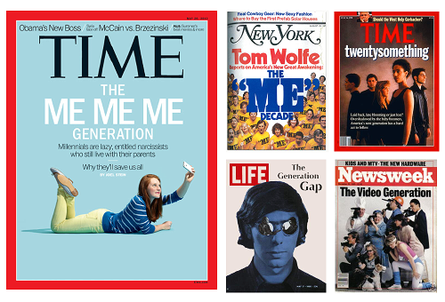
Offensive and illegal? Absolutely. Accurate? No. Like other stereotypes based on race, religion, and age, the facts about Millennials tell a different story.
They aren’t first “all about me” generation. The Baby Boomers were the first given that label by social pundits. Then each generation thereafter. It’s true Millennials are different from their parents and grandparents today. But not so different from their parents and grandparents when they were young. “They [Young People] have exalted notions, because they have not been humbled by life or learned its necessary limitations; moreover, their hopeful disposition makes them think themselves equal to great things -- and that means having exalted notions.” Aristotle, circa 320 BC
More Millennial myths fall to facts. Most are more loyal to their employers than Baby Boomers were (The White House 15 Economic Facts about Millennials). They have higher job satisfaction overall than Boomers or Gen Xers (Journal of Business and Psychology). In general, they don’t need corporate parenting because, “They are skilled with technology, determined, diverse, and more educated than any previous generation” (The White House 15 Economic Facts about Millennials). Millennials aren’t lazy as a whole: “59% of them, in the latest poll, said competition is “what gets them up in the morning”, compared with 50% of baby-boomers”(The Economist).
What are an employer’s takeaways when it comes to generational differences among workers?
- Diversity is strength. Hiring a diverse workforce gets you the best of all generations. Not just skills, but perspectives. Can you see through the eyes of someone thirty years older or younger? Might they have knowledge you don’t? The trick to hiring a diverse workforce? Hire the best candidates.
- Generations have more similarities than differences. “They [workers in each generation] want roughly the same things regardless of when they were born: to be given interesting work to do, to be rewarded on the basis of their contributions and to be given the chance to work hard and get ahead” (The Economist).
- Stay with the times! It’s not just Millennials that expect employers to embrace technology and efficiency, sensible/flexible work schedules, tailored benefits and compensation, and good communications. “If the rate of change on the outside exceed the rate of change on the inside, the end is near” Jack Welch
- Hire and engage individuals, not stereotypes. Whether laziness and entitlement may be more prominent in one generation than another doesn’t matter. Savvy employers have the skills and tools to hire and engage individuals based on their qualifications and strengths.

