An Overview of Gov. Bill Walker’s State of the State Address
By ANVCA Staff | 20 December 2017

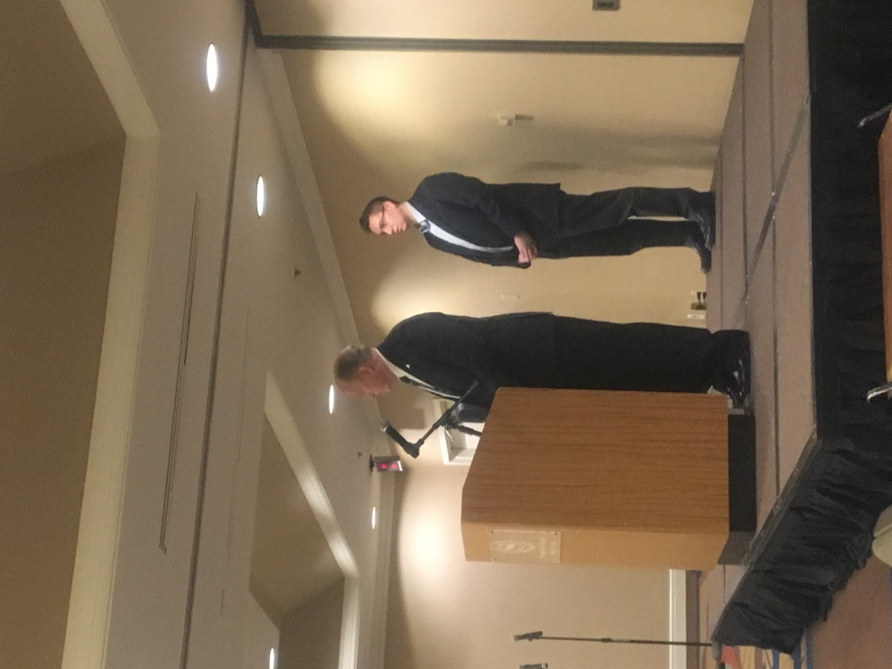

On December 18, 2017, Governor Bill Walker addressed ANVCA Members, Partners, and others involved in the ANCSA community, over lunch at the Sheraton Hotel in downtown Anchorage. Noting the amount of oil and gas developers in the room, he immediately launched into a discussion of the future of natural resource development in Alaska.

Noting that oil has large potential as a “revenue generator,” he shared that natural resource development was a huge priority of his since his term began as a Valdez City Council member in 1976. During that time, he says, he saw huge economic opportunity with the construction of a potential pipeline. “Every Alaskan should benefit from this project,” Walker said as he shared his sentiments of the time. “There is no excuse that Alaska should not be prepared for a future in resource development.”

In early 2017, the opportunity to realize that goal became international in scope. Upon his return from a meeting with President Trump in Washington, D.C., Governor Walker had a meeting with President Xijin Ping of China, at the Captain Cook Hotel in Anchorage. Instantly, Walker said, a collaborative relationship was formed between the two heads of state; with a few other heads of business present at the meeting, China would become the first Asian country to engage in a direct business partnership with the State of Alaska later that year, on Nov. 9, 2017.

[Juneau Empire: Walker signs landmark gas pipeline deal]

The benefits of this deal, Walker told the crowd, were far reaching and not just within the scope of gas development. As many people may know, China is the world’s top consumer of natural resources. Recently, the environment has also become a top priority, as over-development has been shown to have negative impacts. Thus, this new resource development opportunity, which is estimated to bring in approximately $8-10 billion annually to the Alaska’s economy, would have the further potential to reduce approximately 80 million tons of CO₂ emissions in China.

Moreover, Walker said, this new deal has the potential to positively impact and strengthen our existing trade partnership with China, with whom we already trade seafood. He also mentioned the possibility of establishing direct flights between China and Alaska, potentially having a positive impact on our tourist economy.

Along the lines of international partnerships and resource development, Walker also mentioned the positive implications of developing the 1002 study area, the area of the Alaska National Wildlife Refuge currently being evaluated for oil and gas development. Listing job creation and a long term energy solution as the top priorities, he mentioned that relationships with international companies are now pointing towards interest in the potential development. “The pipeline deal with China is only ONE advantage,” Walker said.

Another statewide priority, Governor Walker mentioned, was an increase in public safety spending. Citing the rising crime rates all over the state, Walker advocated for more prosecutors and criminal justice reform. He proposed a $34 million budget for village public safety officers and Alaska State Troopers, with sensible reductions in spending in other areas.

To address deferred maintenance issues all around the state, Walker also mentioned $2 billion in spending for deferred maintenance projects. Not only does this have positive potential for Alaskan jobs, it would have a $1.4 billion impact on Alaska’s economy, according to Walker. In order to subsidize this, he proposed a three-year-long 1.5 % payroll tax to pay for these deferred maintenance projects.

