FIVE QUESTIONS – AND ANSWERS – ABOUT THE GENERAL WELFARE EXCLUSION FOR ALASKA NATIVE CORPORATIONS

Providing financial assistance for the general welfare of shareholders and their relatives has been a long-standing policy for many Alaska Native Corporations (ANCs). Historically there was little relevant guidance from the IRS on whether the recipient benefits were taxable, yet ANCs were required to issue Form 1099 reporting income to the recipients as well as filing the 1099 with the IRS. In 2014, the IRS published Rev. Proc. 2014-35, which provides the framework for treatment and exclusion of income and income tax reporting of general welfare benefit payments.

The following questions and answers provide guidance and insight for the tax treatment related to ANCs based on these IRS procedures.

1. What types of entities are eligible to make payments that can be excluded from recipients’ income?
Indian tribal governments, which under Internal Revenue Code Section 139E(c)(1) specifically includes any agencies or instrumentalities of an Indian tribal government and any Alaska Native Regional or Village Corporation.

2. What qualifications must individual recipients meet to be eligible to exclude payments from income?
An individual must be a qualified member of an Indian tribe or a qualified non-member. Qualified members of Indian tribes are defined as individuals who meet the requirements established by applicable tribal law for enrollment in the tribe. Federally recognized tribes can be found in the Federal Register, Indian Entities Recognized and Eligible To Receive Services From the United States Bureau of Indian Affairs. Qualified non-members include anyone who is a spouse, former spouse, legally recognized domestic partner or former domestic partner, ancestor, descendant, or dependent of a tribe member.

3. What are the eligible entities’ requirements for establishing a qualified program related to benefit payments?
To qualify for exclusion, the programs must meet the following criteria:
(a) Be provided pursuant to a specific tribal government program;
(b) Have written guidelines specifying how individuals may qualify for the benefit;
(c) Be available to any tribal member, qualified nonmember, or identified group of tribal members or nonmembers who satisfy the program guidelines, subject to budgetary restraints;
(d) Ensure the distribution of benefits from the program not discriminate in favor of members of the governing body of the tribe;
(e) Provide that the benefit is not compensation for services;
(f) Make certain the benefit is not lavish or extravagant.

4. What benefits can be provided under a program?
Benefits can include, but are not exclusively limited to:
(a) Housing programs.
(b) Educational and jobs programs.
(c) Elder and disabled programs.
(d) Other programs, including transportation to essential public facilities, transportation and lodging while away from home for medical care, assistance in urgent circumstances, relocation for displaced individuals, and payment for nonprescription drugs.
(e) Cultural and religious programs.

5. What are general guidelines to determine when a Form 1099 need not be issued?
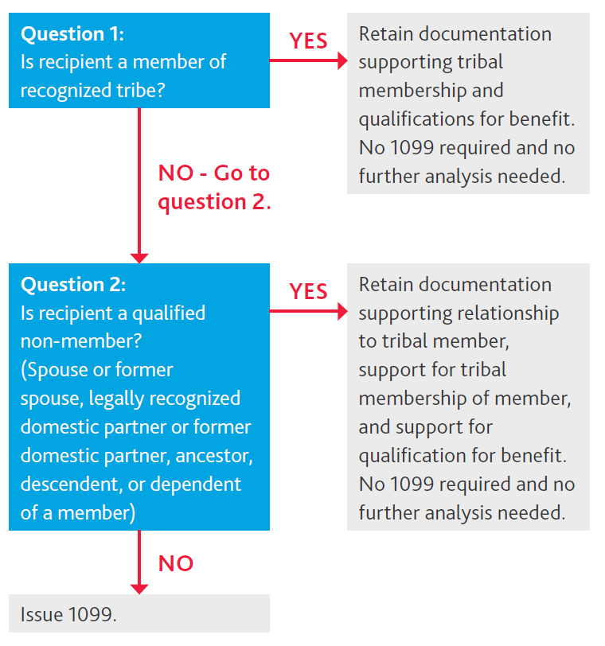

Your local BDO Anchorage Tax Partner Chad Estes and Tax Senior Manager Zac Rankin are available to discuss how these procedures affect your ANC.
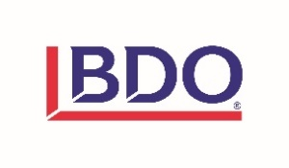
Chad Estes Zac Rankin
907-770-2283 907-770-2232
cestes@bdo.com zrankin@bdo.com

