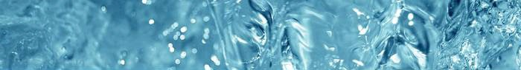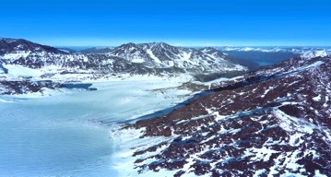
Our Company
Alaska Glacier Products, LLC (AGP) is Alaska’s only provider of pure bottled glacier water. AGP bottles and sells glacier water in a variety of sizes for premium, value, and private label beverage markets. The company has distribution contracts in Alaska, Hawaii, the continental United States, and Asia. Customers include national wholesalers, grocery store chains, health food stores, tourism and travel industry, food service, restaurant, convenience stores, and retail outlets.
Our Source
Alaska Glacier Products source is the pristine Eklutna Lake fed by the Eklutna Glacier. Measuring 7 miles long and 200 feet deep, Eklutna Lake was carved over 10,000 years ago in the Holocene time period. Located just 37 miles outside of Anchorage in the Chugach State Park (a 400,000 acre state-­‐protected area), Eklutna Lake is nestled high in the jagged peaks of Alaska’s Chugach Mountains. The mineral composition of the surrounding earth and protected alpine terrain, have influenced the glacier water with exceptional measures of alkalinity, dissolved solids and mineral balance. Distinct from surface and ground water sources that have been contaminated by human and natural causes, Eklutna Glacier melts slowly from the oldest ice underneath the glacier to form Eklutna Lake. The result is a completely pure and great tasting drinking water. In contrast to depleted aquifers, Eklutna Lake is continuously fed by the Glacier at an estimated recharge rate of 175,000,000 gallons daily. AGP is committed to being a careful steward of this precious resource, using less than .1% annually.
Our Facility
Alaska Glacier Products bottles water at a state-­‐of-­‐the-­‐art bottling facility located at the base of Eklutna Lake. The company uses a fully automated, multi-­‐line, bottle-­‐blow molding, filling-­‐and-­‐ packaging facility completed in 2015, and is one of only a few in the world located near an above ground glacier water source. Installed capacity is 150-­‐200 containers per month; equivalent to 288,000 cases of 500 mL bottles, with optional expansion capabilities on contiguous property at the water source.
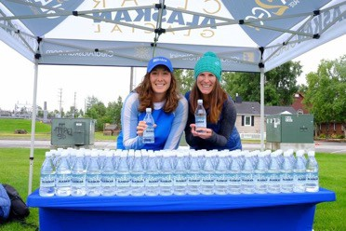
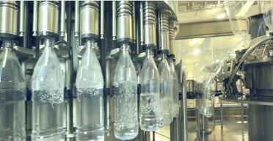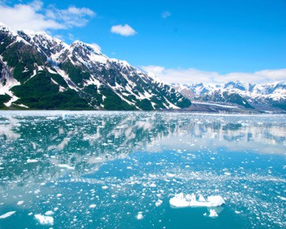
Our Commitment
Alaska Glacier Products is committed to reducing emissions, conserving energy, and efficiently managing transportation and worldwide logistics. All bottles utilize recycled PET-­‐1 plastic, are BPA-­‐free, and boxes are made from 50% recycled paper product. Product is backhauled on what would be empty ocean-­‐going vessels headed back to their mainland U.S. ports. Their Alaska location provides AGP with unique shipping proximity to both the USA and Asia. AGP is a family-­‐owned, small business deeply rooted in Alaska for four generations. The company is actively involved in and donates to sports and fitness groups, Alaska Native organizations, environmental study and conservations efforts, people in crisis, and entrepreneurial initiatives. AGP hires locally and provides benefits to their employees.
1

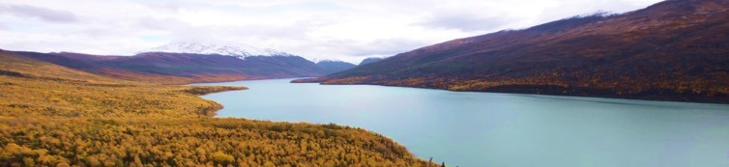

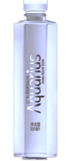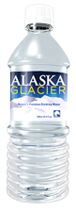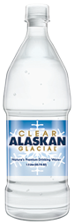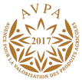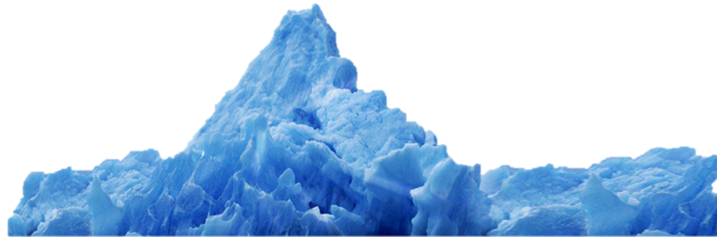Our Products
Alaska Glacier Products offers natural premium glacier water that is naturally high in pH (seasonal average 7.8) and rich in natural minerals and ions. It’s portable, pure refreshment to rejuvenate the body and promote better health. AGP’s water is internationally acclaimed for its superior taste, and has won numerous quality awards. Alaska Glacier Products was awarded the Silver Medal from the Fine Water Society, and was the only USA water to receive a medal at the 2017 Gourmet Waters International Competition.

Our premium brand, Clear Alaskan GlacialTM offers local, national and international customers superior tasting pure water from Alaska’s untouched glaciers. Five sizes are available and sold as single bottles, cases, and in 6-­‐pack bundles.
Our value brand Alaska GlacierTM provides Alaskan wholesalers and retailers an economical local source option, versus having to pay freight to ship bottled water to Alaska. Large format multipacks are available.
Private Label Branding, Co-­‐Branding, and Co-­‐Packaging Services are available for customers who meet minimum quantity requirements.

Our Competitive Advantage
PURE, NATURAL AND WILD- Alaska Glacier Products location and bottled water brands are powerful associations with nature’s last frontier. The world is enchanted with Alaska and its untouched wilderness. Alaska water has immediate recognition as clean, pure, and abundant.
GENUINE QUAILTY GLACIER WATER- This is the real deal – from a real glacier – with naturally high pH and superior taste. Many other bottled waters in the marketplace are made with artificial pH and synthetic mineralization. Alaska Glacier Products water is bottled the way nature produced it, without added fluoride or chlorine.
SUSTAINABLE STEWARDSHIP- Alaska Glacier Product’s Eklutna Lake source is a rare and plentiful resource with untapped capacity. Unlike many other bottled waters, AGP’s water is not municipal tap water and is not being pulled from aquifers that are dangerously depleted. AGP’s source, business and brands are based on responsible authenticity.
MARKETPLACE ADVANTAGE- Alaska Glacier Products equal proximity to the Western USA and Asia provides a strategic advantage in delivering bottled water to these two population centers.

2

Financial Overview
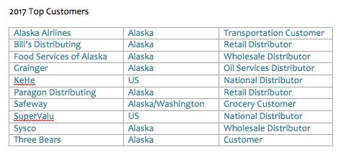
Alaska Glacier Products, LLC’s annual sales revenue has grown over 50% since the company’s 2014 reorganization. AGP’s focus on distributor sales channels maximizes both the company’s geographic coverage and retail volume. The addition of multipack offerings has expanded the company’s wholesale and retail offerings. New high volume customers acquired in 2017 include Safeway/Carrs/Albertsons and Fred Meyer grocery store chains.

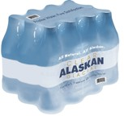
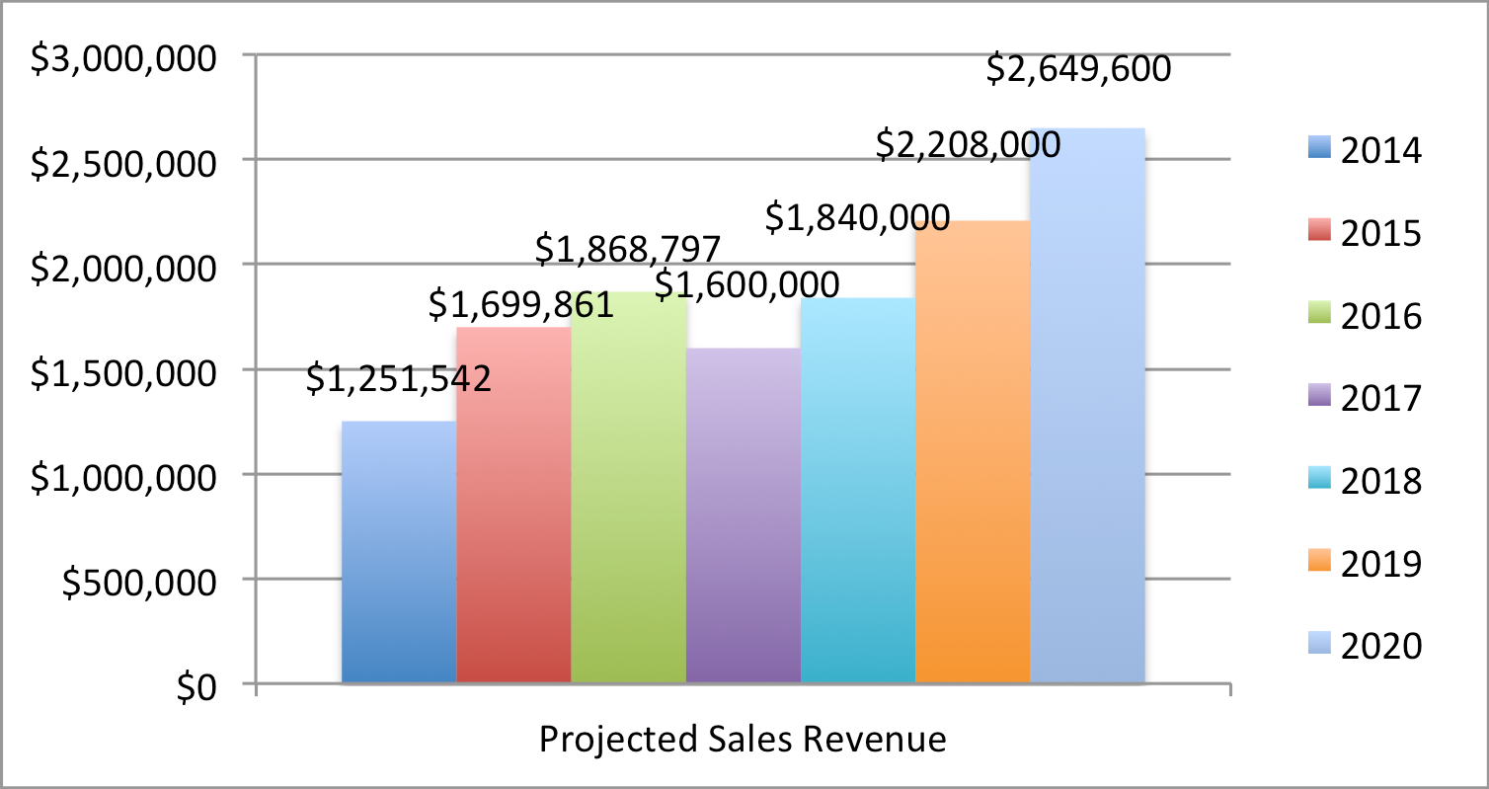AGP’s positive sales revenue trajectory is strong, although impacted by Alaska’s current economic recession and a cold, wet summer. AGP estimates a 20% decrease in 2017 vs. 2016 sales. This is comparable to the Alaska retail sector which reports a 10-­‐ 30% drop in sales. AGP’s long term projected sales growth based on a Compounded Average Growth Rate (CAGR) of +15% annually estimates the company’s annual sales revenue at $2.5M by 2020.

In addition to developing organic growth in existing channels, AGP is also negotiating several new contracts that would provide significant revenue increases. These include: wholesale retailer ($600,000/year), tour transportation company ($600,000/year), government entity ($180,000/year), international airline contract ($2,400,000/year), Midwestern distributor ($500,000/year), Pacific Northwest distributor ($250,000/year), Pacific Northwest grocer ($100,000/year), regional co-­‐packing contract ($100,000/year), and two foreign beverage distributors ($150,000/year).

3

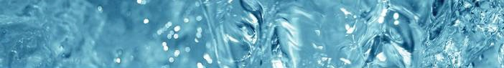

Alaska Glacier Products, LLC’s operating expenses increased from 2014 to 2016 in order to support the company’s facility build-­‐out and sales program implementation. In 2016, AGP’s sales continued to increase while the cost of goods purchased decreased. This is due to the volume-­‐based efficiencies that will continue to be realized as production increases. In 2017, the company actively streamlined expenses by reducing labor costs and renegotiating leases and loan expenses. Lowering these three line items is anticipated to reduce the company’s annual expenses by $1m annually. Based on these projections, AGP’s sales will outpace expenses in 2019.

2014

Note: 2016 expenses include asset valuation modification (for tax purposes) and increase in depreciation
$4,000,000
$3,500,000
$3,000,000
$2,500,000
$2,000,000
$1,500,000
$1,000,000
$500,000
$0
$3,410,300
$3,000,000
$2,300,000
$2,450,000
$1,844,312
$1,072,722
2015
2016
2017
2018
2019
2020

Annual Expenses

$1,200,000

$1,000,000

$800,000

$600,000

$400,000
Cost of Goods Labor
AGC Loan
Land Lease
$200,000

$0
2014 2015 2016 2017 2018

DISCLOSURE. This presentation was prepared exclusively for the benefit and internal use of the company to whom it is directly addressed and delivered (including such company’s subsidiaries, the “Company”) in order to assist the Company in evaluating, on a preliminary basis, the feasibility of a possible transaction or transactions and does not carry any right of publication or disclosure, in whole or in part, to any other party. This presentation is for discussion purposes only and is incomplete without reference to, and should be viewed solely in conjunction with, the oral briefing provided. Neither this presentation nor any of its contents may be disclosed or used for any other purpose without the prior written consent of Alaska Glacier Products, LLC (AGP). The information in this presentation is based upon management forecasts and reflects prevailing conditions and our views as of this date, all of which are accordingly subject to change. AGP’s opinions and estimates constitute AGP’s judgment and should be regarded as indicative, preliminary and for illustrative purposes only. In preparing this presentation, we have relied upon and assumed, without independent verification, the accuracy and completeness of all information available from public sources or which was provided to us or which was otherwise reviewed by us. In addition, our analyses are not and do not purport to be appraisals of the assets, stock, or business of AGP or any other entity. AGP makes no representations as to the actual value that may be
received in connection with a transaction nor the legal, tax or accounting effects of consummating a transaction. 4

