Member Spotlight: Chitina Native Corporation and Chitina Electric, Inc.
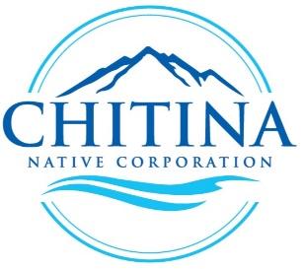
Chitina Native Corporation
As an annual event that marks the start of spring, the Ahtna people of the Copper River region begin their harvest of Copper River King and Red Salmon. As recognition of this event marks the awakening of the small village of Chitina, the employees of Chitina Native Corporation (CNC) have been working on projects and board initiatives throughout the winter.
Chitina Native Corporation (CNC) is a wholly owned Native corporation in the Ahtna Region, with 275 shareholder and was established in 1973. CNC has four subsidiaries, Chitina Electric, Inc., Chitina Diversified Services, LLC, CNC Real Estate, LLC and Taral Enterprises, LLC. These subsidiaries focus on construction, power generation, professional services, janitorial services, real estate investments, property management, tourism development to include the management of two park properties, and ownership of a local mercantile and gas station.
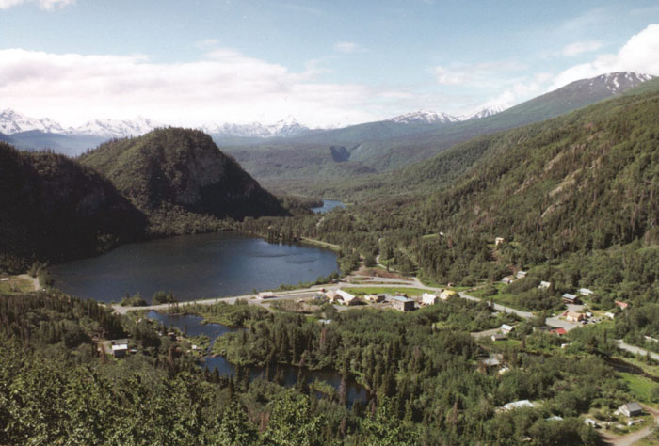
(Chitina Alaska)
A little over a year ago, CNC hired Ed Herndon for a new position as CEO. Ed has grown several companies and earned a bachelor’s degree in marketing and management from UAA with a long history of working with Alaska Native corporations. CNC experienced more opportunities within its government work and commercial lines in the last few years. This work resulted in the need of an experienced executive with a range of knowledge, skills and abilities to pull together resources and focus on growth.
“Chitina Native Corporation has a long history of very conservative decisions, however with recent opportunities and a year behind us of building out infrastructure, we find that we are ready to pursue our growth objectives” says Ed Herndon.

Anne Thomas, President of CNC and sitting ANVCA Board member said “in addition to our local offerings we are excited about the growth potential and opportunities that Chitina Native Corporation can find at a national level.”

Chitina Electric, Inc.
One of CNC’s subsidiaries, Chitina Electric, Inc., has been working throughout the winter on projects and has seen the best opportunities for growth both in the region and at various locations in the lower 48.
In 1981 Chitina Electric, Inc. (CEI) was created and commenced operations in 1982. CEI was formed to provide electricity for the native village of Chitina. Since that time, CEI has increased ten-fold and has expanded its delivery service capacity from its original 15 consumers to a 5-mile radius, generating and supplying electrical power to consumers via fossil fuel. More recently, CEI has taken a closer look at the possibility of Hydroelectric power to offset the ever-increasing cost of diesel and continues to work with stakeholders to develop this project.
CEI also performs Construction and has established itself as a key prime contractor supporting the Department of Labor. Primary areas of focus include general and specialty contracting, value engineering and design build capabilities. This experience has provided some key insight and valuable past performance as CEI continues to pursue construction work within the 8(a) program.

To reach Ed Herndon with any inquires please email, eherndon@chitinacorp.com

