California’s Infant/Toddler Learning and Development Foundations Workshop
contact: Paulina Escamilla-Vestal | tel: 209.609.1681 | email: pvestal@WestEd.org | www.pitc.org

Who Should Attend
- Infant/Toddler program administrators
- Infant care teachers working with children birth to 36 months
- Center-based or family child care providers

Goals of the Workshop
This workshop, offered in local communities across California, provides an overview of California’s Infant/Toddler Learning and Development System. The workshop will focus on the California Infant/Toddler Learning and Development Foundations, a major publication by the California Department of Education, Early Education & Support Division.

Designed to support continuous improvement efforts of infant/ toddler programs, the workshop will help participants to:

- Understand the five components of the California Infant/ Toddler Learning and Development System;
- Deepen their understanding of the Infant/Toddler Learning and Development Foundations;
- Apply the concepts covered in the Infant/Toddler Learning and Development Foundations in their work; and
Event Location:
San Joaquin County Office of Education
Wentworth Education Center
Burwood 1
2707 Transworld Drive
Stockton, CA 95206
- Plan effective infant/toddler curriculum
Brought to you in partnership with the California Department of Education, Early Education & Support Division; WestEd, Center for Child and Family Studies, PITC Partners for Quality; and San Joaquin County Office of Education

Infant/Toddler Learning and Development Foundations

This 6-hour workshop will focus on I/T Learning and Development Foundations. The foundations describe competencies children typically attain during the birth-to-36-month period. Participants will explore CDE’s Infant/Toddler Learning and Development Foundations, DVDs, and related materials.

Date: Saturday, February 25, 2017
Time: 8:30 a.m. to 3:30 p.m.

- Registration fee: $20
- Breakfast & Lunch provided.
- Books will be provided courtesy of the sponsors.
- Participants will receive certificates indicating professional growth hours earned.

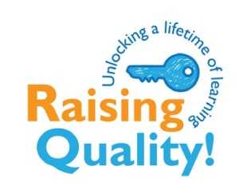
Please register online at http://conta.cc/2bTT5TP
Questions? Please contact Christine Carrier at San Joaquin County Office of Education, ccarrier@sjcoe.net or 209.468.9083

