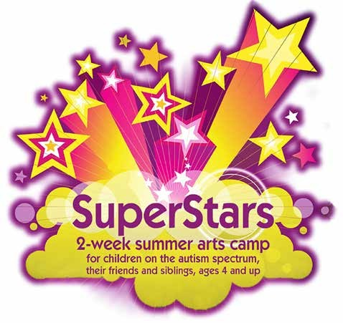
*

SuperStars Camp is a program of the Autism Society of Southeastern Wisconsin


and is also supported by:
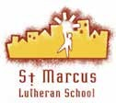

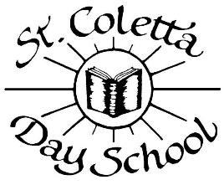

“SuperStars has established a culture where kiddos on the spectrum are accepted and where their unique talents are praised and encouraged.”

~ Andrea, SuperStars parent

St. Marcus School, 2215 N. Palmer Street, Milwaukee
- 2 weeks, June 18-22 and June 25-29, 9 to 11:30 am, Monday - Friday
- Space limited to 22 children, ages 4 and up
Folk Tales from Around the World

Music Drama Art
Movement Puppets
Theatre Games
Sing Dance
Friendships Fun

- Teachers certified in autism, arts, education
- Healthy snacks provided
* Campers with other special needs are welcome!
The SuperStars Camp ends with all participants
in a show for family and friends on
Friday, June 29th at 11:00 a.m.

COST: $150 per child, payment due by June 15, 2018.
Children can join the program while in progress, but pre-registration is requested. For details on program activities, contact director Julie Borouchoff at 414-699-9013.

----------------------------------------- ----------------------------------------------------------------------------------------------------------------------

SuperStars Camp Registration Form
Duplicate this form for each child.
Make check payable to
Autism Society of Southeastern
Wisconsin

Mail to:
Autism Society of Southeastern WI
Attn: SuperStars Camp
3720 N. 124th St., Ste. O
Wauwatosa, WI 53222

Questions? 414-699-9013 or
admin@thesuperstarscamp.org

We will contact you to discuss the individual needs of each child enrolled.

Child’s name Age Parent/Guardian Address, City, Zip Daytime phone number Email address Emergency contact name Emergency contact relationship to child Emergency contact daytime phone number Parent/Guardian Signature Total number children enrolling under same Parent/Guardian
$150 per child = Amount enclosed $

For office use: Date Received Check # Other arrangements made Date follow-up call made

