For information session:

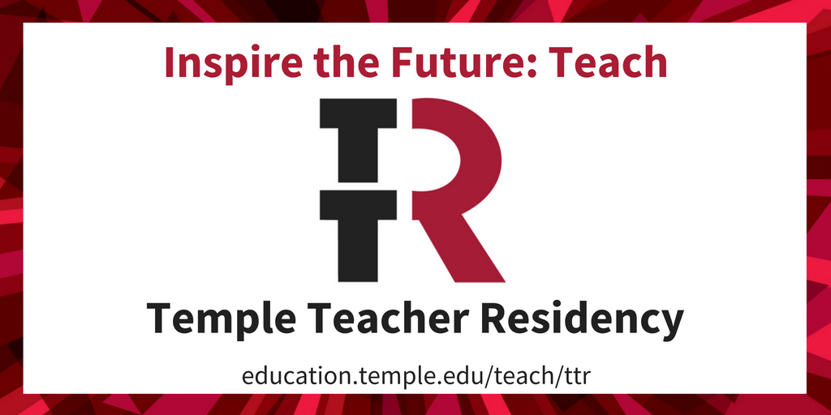

Turn your math or science degree into inspiration!

Temple Teacher Residency will be holding an information session on

February 1 at 4:30pm

Cecil B. Moore Library
2320 Cecil B. Moore Ave
Philadelphia, PA

Learn more or RSVP at
http://bit.ly/1YvyxD3

For webinar:

Turn your math or science degree into inspiration!

Temple Teacher Residency will be holding an
online information session on

February 8 at 5:30pm

Learn more or RSVP at
http://bit.ly/1YvyxD3

