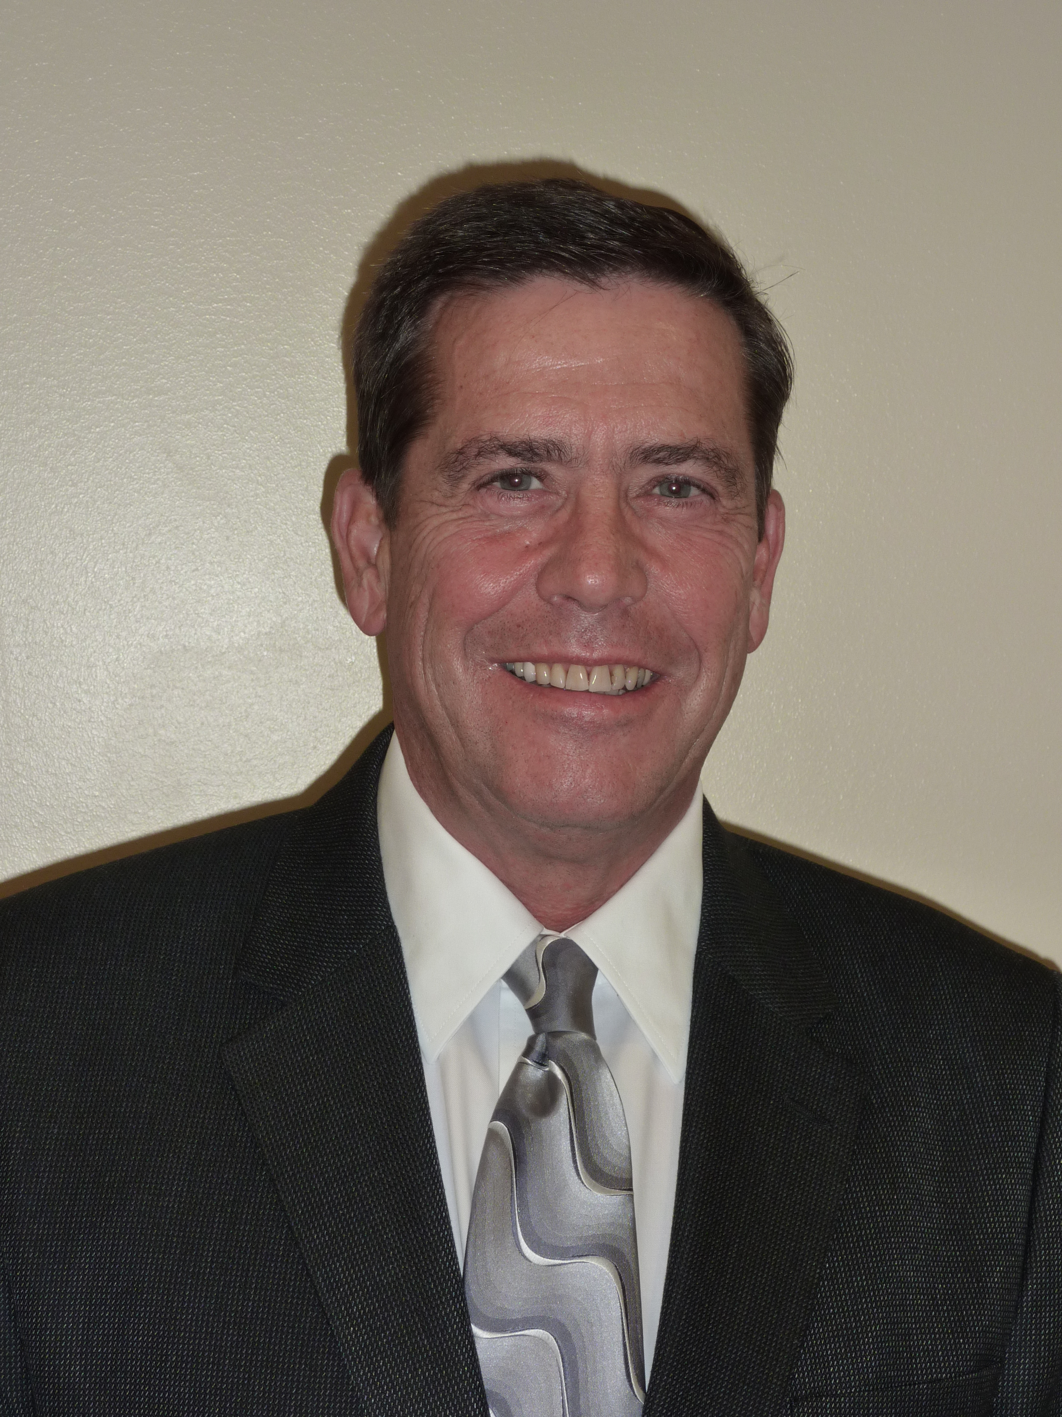

Greg L. Ledgerwood M.D.
Member AAFP, ACAAI-, AE-C
Private Practice, Brewster, WA

I graduated from Washington State University in 1967, and then University of Washington School of Medicine in 1971. I did my post-graduate work at Kaiser Foundation Hospitals in San Francisco, California and the USAF, serving as head of FP/Allergy at Fairchild Air Force Base in Spokane, WA. It was during this time that I also became board certified in Family Medicine and did a fellowship in Allergy at Travis Air Force Base in California. I began my private practice in Omak, WA in 1974, specializing in Primary Care and Allergy, Asthma and COPD. I was the physician coordinator for the Clinical Clerkship for the Omak WAMI site (the first site for the U of WA Medical School). I have been a national lecturer for the AAFP, a principle faculty teaching Spirometry to primary care providers nationally, and, served as Chair for providers with the Washington Asthma Initiative. I have participated in the education of medical students, residents, and medical providers my entire 40 plus years in practice. I currently practice part time and continue teaching in the field of Chronic Respiratory Disease.

