Trinity High School - Birding and Conservation Club

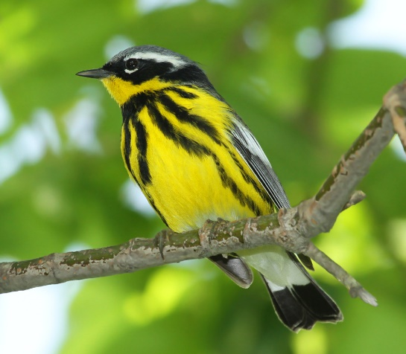
Magnolia Warbler

* Upcoming Walks/Events:
Saturday, May 19th - Stoney Creek Valley
Dominic Mirarchi will lead us through the Stony Creek area to see, hear, and learn about the various species of warblers and other spring birds. In past years we’ve spotted a Yellow-breasted Chat, Pileated Woodpeckers, Blue-winged Warblers, and Yellow-throated Vireos to name a few. Meet at the power line by the PPL substation along Stony Creek Road at 7:00 a.m. Look for the Trinity Birding and Conservation yard sign. Click here to sign-up.
* Events in the Planning Stages:
Walk with John Dale; former president of the Appalachian Audubon Society. Mr. Dale will provide instruction, tips, and field experience in Central Pennsylvania locales.
Steven Saffier, Program Manager of Bird-friendly Communities in Audubon, Pennsylvania, will help us transform Trinity High School campus to an Audubon Bird Habitat.

