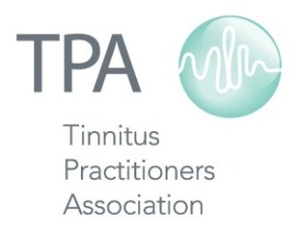

2017 Schedule of TPA Courses and Conferences
Continuing Education Events

Jan 13-14 Associate Course Maui, HI

Feb 20-24 TPA Auction Online

Mar 16 CEU Webinar Online

Apr 5 Member Social at AAA Indianapolis, IN

May 4-6 Sound Sensitivity Conference Dallas, TX

Jun 23-24 Associate Course New Orleans, LA

Aug 10-11 Fellow Course Boston, MA

Sep 25-27 Member Social at ADA Uncasville, CT

Oct 20-21 Sound Therapy Expo Memphis, TN

Nov 9 CEU Webinar Online

