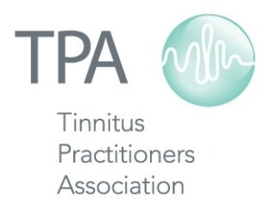

Schedule of TPA Courses, Conferences and Events

2017

Jan 13-14 Associate Course Maui, HI

Feb 20-24 TPA Auction Online

Mar 16 Webinar Online

Apr 6 Member Social at AAA Indianapolis, IN

May 4-6 Sound Sensitivity Conference Dallas, TX

Jun 23-24 Associate Course New Orleans, LA

Aug 11-12 Fellow Course Boston, MA

Sep 25-27 Member Social at ADA Uncasville, CT

Oct 20-21 Sound Therapy Expo Memphis, TN

Nov 9 CEU Webinar Online

2018

Jan 12-13 Associate Course Maui, HI

