FIELD DAY WILL BE HELD ON
WEDNESDAY, MAY 16th
9:00-12:00 (Rain Date May 23)
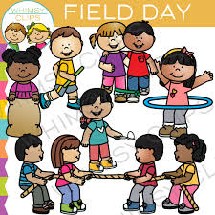
What is Field Day? Field Day is a fun day filled with games and activities where students can show off the skills they have learned in physical education class throughout the year.
*Please send your child with a water bottle.
*Consider having your child wear a hat and sunscreen to protect them from the sun.

After Field Day, first and second grade students have the opportunity to participate in the Shoe Tying Olympics. Students compete against one another to see how fast they can tie their shoes. This is a very important skill to have, so keep
practicing at home!!
------------------------------------------------------
FIELD DAY VOLUNTEERS NEEDED!
PLEASE INDICATE THE TIMES YOU WOULD LIKE TO VOLUNTEER:
9:00-10:00______
10:00-11:00_____
11:00-12:00_____
ALL DAY________

CHILD’S NAME________________ TEACHER_______________

PARENT’S NAME_______________ PHONE #_______________

PLEASE RETURN THIS FORM TO
MR. HOROWITZ OR YOUR CLASSROOM TEACHER

