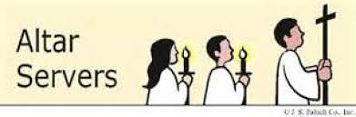

WHO WANTS TO BE AN ALTAR SERVER???

YOU DO!!!!

Altar server training is scheduled for

Saturday, January 20, 2018

From 2:00 p.m. to 3:30 p.m.

In the corpus Christi church

Interested 3rd thru 8th graders are invited to attend

Contact mike martin at 251-391-8666
if you have any questions

