March 30, 2018

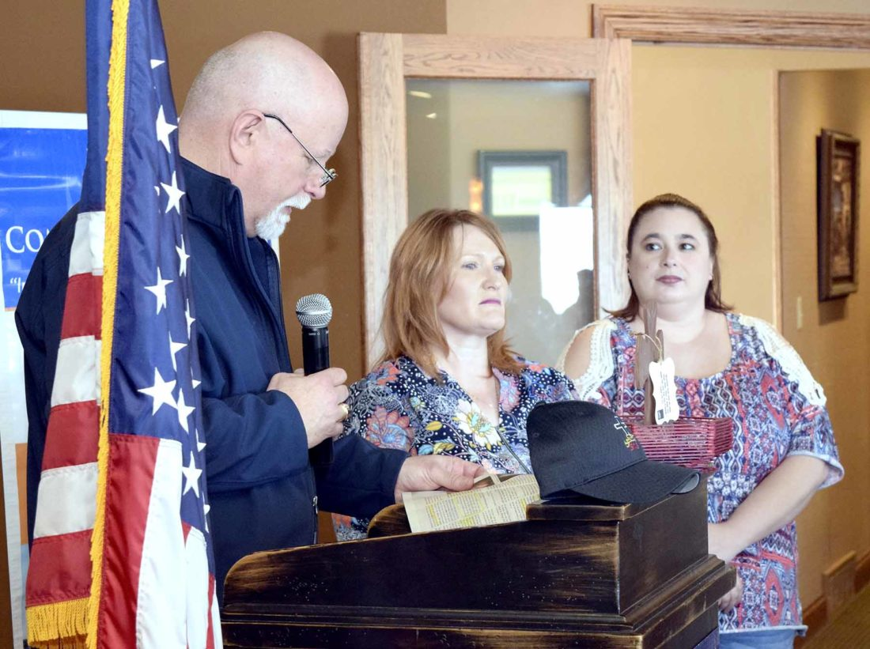
-Messenger photo by Joe Sutter
Rev. Al Henderson presents a Heroes of the Heartland award to Rebecca Kiesecker, center, and Michelle Brown, who stopped to help a man in a serious accident and then waiting in the emergency room, staying in contact with the man’s father.
It was a simple ladies’ day out for Rebecca Kiesecker and Michelle Brown. They’d gone to the casino in Jefferson, but weren’t able to get in because one of them hadn’t brought an ID. So they decided to go home a different way.
That’s when they came across the scene where a semi-truck had hit a delivery van. Both drivers ended up going to the hospital.
Before paramedics got there, Kiesecker and Brown had already talked with the van’s driver, talked to his father over the phone, who began driving there from Omaha, and took his information to share with rescue crews later.
These two were honored as Heroes of the Heartland at the annual Heroes Luncheon Wednesday put on by Serving our Servants and the Fort Dodge Community Foundation and United Way at Willow Ridge.
The Rev. Al Henderson, chaplain for multiple agencies and founder of SOS, presented their award and told their story.
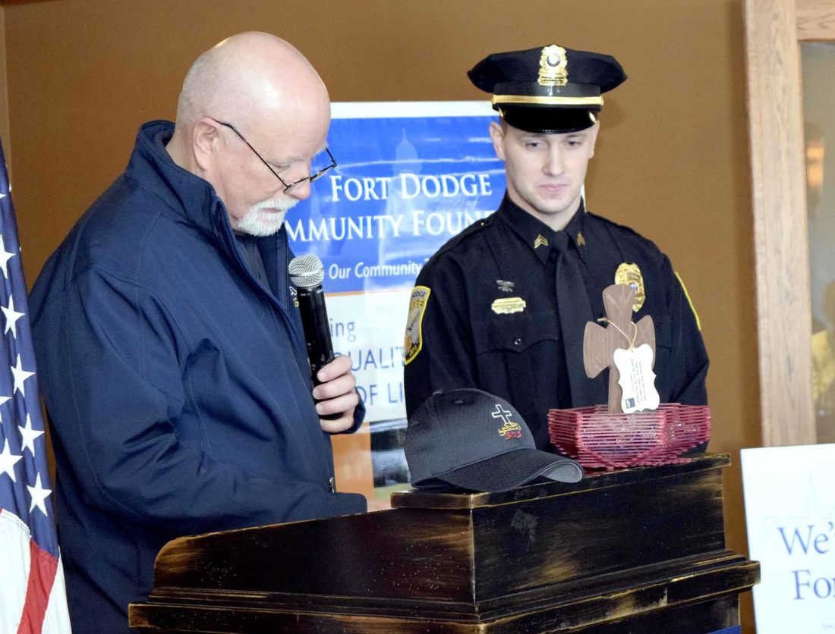
-Messenger photo by Joe Sutter
Fort Dodge Police Sgt. Zach Stanley, right, accepts an award on behalf of Officer Caitlin Keeland from the Rev. Al Henderson. Keeland was nominated by her peers for SOS’s Servant of the Year award.
The two women didn’t just stop by the road. They went to the ER at UnityPoint Health — Trinity Regional Medical Center and gave the patient’s information to the nurse in charge. They waited there in the waiting room, staying in contact with the man’s father. Eventually, the man did invite them back to the ER so he could thank them for what they did, Henderson said.
“They stayed with the patient all the time until Life Flight came and took the patient away,” he said. “Quite a pair, who got interrupted on a ladies’ day out.”
Two others were honored as Heroes of the Heartland — “men and women who rose up as the situation called them,” Henderson said.
Ryan Buman, of Des Moines, had been in Fort Dodge for Frontier Days last year as one of the costumed presenters. He happened to be up that night when a man robbed the root beer tent and set it on fire.
Not only did Buman spot the fire, but the retired firefighter and emergency medical technician chased the suspect and helped apprehend him.
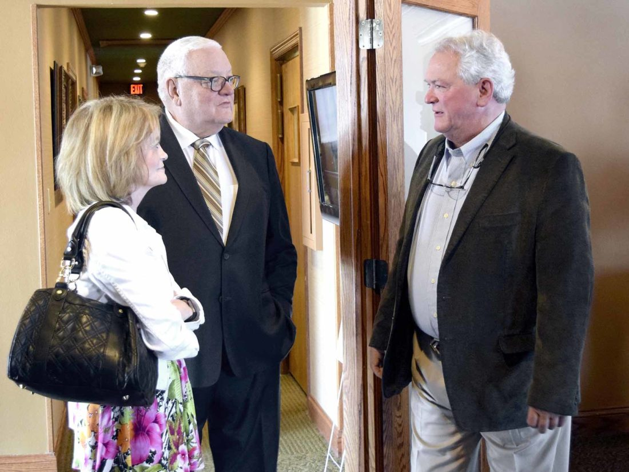
-Messenger photo by Joe Sutter
Dr. Dan Cole, left, and his wife Sheila Cole talk with Jon Copper after the SOS Heroes award ceremony Wednesday noon. Dan Cole and Copper were honored for their work at the UnityPoint emergency room in Fort Dodge.
“In flip-flops,” Buman said.
The local fire chief has said that without Buman’s help the suspect might never have been caught, Henderson said. And with the root beer tent next to the Fort’s stockade, it was only thanks to a quick response that the whole thing didn’t go up in flames.
Also receiving the award was Dan Riley, of Riley Plumbing, who stopped to help when police were trying to arrest a wanted subject. The man had punched an officer and started running.
“Nearby were other officers who converged to attempt to apprehend this man. Also among them was a plumber,” Henderson said. “Former officer, Fort Dodge Police Department and Gowrie, he happened to be in the same area and he stepped up to help. He actually was wounded slightly himself in that apprehension.”
Two Servant of the Year awards were given out for officials who were nominated by their peers in their respective departments.
Dr. Dan Cole, who Henderson called a “legend in the emergency room,” and Fort Dodge Police Officer Caitlin Keeland received those awards.
Cole was instrumental in bringing the Life Flight helicopter to the region, and was medical director of the emergency room for more than 20 years.
“I have had the joy of working with this man in a variety of situations, and I just rejoice at the nomination and the acceptance by our community of this year,” Henderson said.
Keeland was praised by her coworkers for a willingness to take all calls with no complaint, Henderson said.
She also regularly jumps calls, Henderson said — meaning she’s quick to volunteer that’s she’s close to a call and respond herself. She has volunteered her time for activities such as the dunk tank at a recent BBQ battle, raising money for the department, and helped organize “quite a team” for the Special Olympics’ Polar Plunge this year.
Randy Kuhlman, chief executive officer of the Fort Dodge Community Foundation and United Way, spoke about the many ways volunteers can serve.
“We have the privilege of recognizing some people who have gone above and beyond the call of duty,” Kuhlman said. “There are a lot of different definitions of a hero. Our end of this program is to recognize people who go above the call of duty, so to speak, in making a difference in our community.
“Often times that has to do with helping people less fortunate than them. Other times that has to do with taking an initiative or project or program, and making it something special for our community, to make Fort Dodge a better place to live, play, work and raise our families.”
Kuhlman presented these Community Heroes awards to Susan Ahlers Leman, John Copper and the volunteers of Operation Christmas.
Ahlers Leman got involved with the Fort Dodge Fine Arts Association five years ago.
“It was an organization that had gone dormant. They had 11 members,” Kuhlman said. “And Susan stood up and said we need a good, strong organization like this to promote the fine arts in Fort Dodge. We have a great robust community in the fine arts, and yet they’re operating in silos and not really working together.”
Ahlers Leman stepped up, Kuhlman said, and today the group has 60 members and a storefront on Central Avenue.
Copper has been an EMT and a leader at Trinity’s emergency department for more than 40 years, Kuhlman said.
He also serves on the board of directors for Webster County Conservation, and has volunteered in other ways.
“He’s touched people’s lives and made a difference in their lives in a personal way,”Kuhlman said. “In his world of the EMT, where you’re in an emergency situation and just having a person there to give you a little extra care and concern makes all the difference in the world.”
Operation Christmas, as run by Church Women United, came to an end in 2017 after more than 60 years.
Kuhlman said he was impressed when he first learned the program wasn’t just giving toys to kids; it was also to provide necessities to families in need around the holiday.
The Operation takes 200 volunteers a year, he said, who organize and keep lists by hand with no use of a computer.
“The procedure they follow to get this done is a process that would make FedEx proud,”Kuhlman said.
They start raising funds and collecting donations immediately after Christmas, looking ahead to the next one. Many of the items they give away are new, and the women watch for sales all year to make the best of their donated funds.
Susan Ahlers Leman
Heroes Luncheon

Susan Ahlers Leman is active in many aspects of the Fort Dodge community. She serves on the Iowa Central Foundation Board, The Blanden Foundation Board, United Way and Community Foundation Board, Stage Door Productions Board, Fort Dodge Noon Rotary Board, Fort Dodge Historic Commission, Fort Dodge Council Salary Advisory Board; she is a member of the Iowa State Bar Association, Study Club, 100 Women Who Care, She is a past member of the Fort Dodge Human Rights Commission, North Central Iowa Youth Shelter Care Board, Lakota Girl Scout Board and Past President, RAGBRAI Steering Committee and the Up on Fort Dodge campaign.

Susan is also very active in the Arts in our region, the reason she is being recognized today.

Susan is the president of the Board of Directors of the Fort Dodge Fine Arts Association (FDFAA). In 2015, she actively began working to grow the Fort Dodge Fine Arts Association’s membership, activities and impact. At that time, The FDFAA had 11 members. Susan understood that the arts play a very significant role in employee recruitment, retention, economic development and quality of life. She also knew that there was a plethora of arts organizations, events and enthusiasts in the region, but that there needed to be an organized, formal and professional process to improve communication and promotion of all these arts activities.

She met with the FD Fine Arts Board to begin developing a strategy; she also approached the Fort Dodge Community Foundation with the proposal that this organization provide office, communication and organizational services to help the FDFAA expand its reach in the region. This was agreed upon, and since January of 2015, the FDFAA has grown from only eleven members to sixty members and Supporting Artists in 2018.

Susan also initiated a Patron Drive, which resulted in raising funds that would support the organization and help to hire its first part-time Executive Director. A method to streamline communication, scheduling, calendars and press releases was formed; increased involvement and promotion for youth was instituted by working with the schools and arts teachers to recognize outstanding art students and to help students become involved in the arts; a fund was created at the Fort Dodge Community Foundation, ”Widening the Stage”, to provide grant funds for students to help them participate in the arts (primarily instrument rental and to help facilitate some arts opportunities for youth).

Because of this very successful collaboration between the FDFAA and the FD Community Foundation, both organizations received the 2016 Governor’s Arts Award for Collaboration & Partnership in the Arts. The State of Iowa also recognizes that the arts are critical to the success of our state. By helping the arts grow and flourish in our region, Susan is helping our state become a national leaders as a place to live, work, play and raise a family.

John Copper
Heroes 2018

John Copper has been an active volunteer in the Fort Dodge community for over forty years. He is the oldest son in a family of ten children, the father of twin sons and has been an EMT at UnityPoint Medical Center since 1976.
John was raised to be an active member of his community. When he was growing up, he volunteered with his father during political campaigns, going door to door to support various candidates. This provided a strong foundation that encouraged him to volunteer often in his community.

John serves on the board of directors of the Webster County Conservation. He adopted the Kennedy Brown neighborhood park, mowing the park’s lawn each week during the summers; he has participated in Project AWARE (Iowa’s DNR project that does river cleanup), is a member of the Knights of Columbus, the Moose Lodge, Crimestoppers and participated in and graduated from the Fort Dodge Police Citizens Academy. He is also a member of SOS (Saving our Servants). John served as an advocate for victims of domestic violence, accompanying the victim to court, providing support for these victims as they journeyed through the court system and recovery.

John started a Neighborhood Watch in his Kennedy Brown neighborhood, serving as captain of the group and organizing social gatherings as well as meetings that provided information on neighborhood safety from the Fort Dodge Police Department. John served as a member of the Webster County Sheriff Reserves.

He provides child safety seat checks and education at Fort Dodge Ford Toyota, has provided first aid training for teachers and students at Head Start, the Boy Scouts and many other organizations through the years. He is often seen in the Frontier Days parade, driving the UnityPoint ambulance. John participates in National Night Out, providing EMT support and education for children and their families. He provides EMT support for the Iowa Central home football games.

John helps with annual fundraising for the Leukemia and Lymphoma Society, National Heart Association and the March of Dimes.

John’s career with UnityPoint’s Emergency Department has also provided the opportunity for him to help thousands of people in the most difficult moments of their lives. His knowledge, experience and calm nature provide comfort for them during their time of crisis. He is a member of the National Association of Emergency Medical Technicians, the Iowa EMS Association (and a former board member) as well as the North Central Iowa EMS Association (also a former board member). He served on the UnityPoint Employee Relations Council and the Employee Appreciation Committee. He often served as Santa Claus with Sister Trudy at UnityPoint’s Christmas celebrations as well as visiting pediatric patients who were hospitalized over the holidays. John has also served as a volunteer EMT with LifeFlight.

He has also helped many people when emergencies and accidents occur and he is out in the community or is travelling – he steps in , takes care of the person in difficulty and stabilizes the situation until additional help can arrive. He is pillar of strength to many.

Operation Christmas
Heroes 2018

Operation Christmas was started in 1951 by two women, Cele Sanders and Denise O’Brien, wives of local doctors. The organization grew over the years and involved volunteers from Church Women United, from about twenty local churches. Over 200 volunteers have worked each year to host Operation Christmas. Operation Christmas provides gifts, household items, clothing and food for needy families and individuals for Christmas. Many of these items are donated, which requires lots of sorting and organizing.

Five hundred families were served by Operation Christmas in 2017. Each family must apply to Operation Christmas and list the ages and needs of family members. These names are cross-referenced with other local organizations that help families during the holidays to ensure that there isn’t duplication.

Boxes are collected for months before Christmas; volunteers then number each box that corresponds to a specific family, and the boxes are filled with the items and food the family needs. All names are kept anonymous so that volunteers don’t know who the families are.

Ruth Reed and Gwen Anderson have been the chairs of Operation Christmas for more than 35 years. They have worked in every aspect of the project: Arranging for the locations to host Operation Christmas, receiving donated items (clothing, food, linens), storing the items, sorting, making the boxes for the deliveries, keeping the records, accepting the families’ applications, working the day the families pick up their boxes and even delivering the boxes to the homebound. Ruth and Gwen have been champions for Operation Christmas, but both are quick to deflect any praise to the wonderful volunteers they work with.
Marilyn Savage has been Operation Christmas’s treasurer for many years. Kitty Nellis has helping putting boxes together; Roberta “Bert” and Richard Zahrobsky were in charge of clothing, Christmas decorations, dishes and miscellaneous items; Arlene Opheim worked in the linen department and Rose Marie Skogmo worked in every department.

These extraordinary volunteers have helped brighten the lives of thousands over the past decades. They want to be sure every person, especially the children, have a Merry Christmas.

