Bri
Bridges of Hope
Faithful Response to Mental Health Challenges
A Community Conversation
Thursday, May 18 at 7:00 pm
Evanston Public Library 1703 Orrington Avenue First Floor Community Room

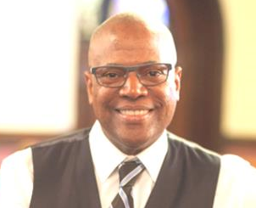 | 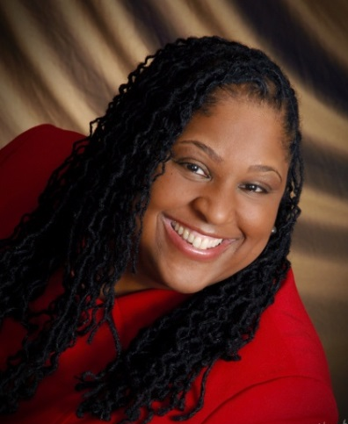 |  | 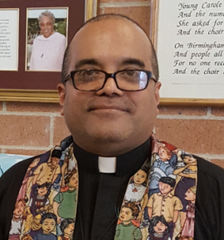
Rev. Dr. Michael C. R. Nabors  Senior Pastor-Elect  Second Baptist Church of Evanston  Reverend Dr. Michael C. R. Nabors is senior pastor of the. He was called to the church in December of 2014 after serving New Calvary Baptist Church of Detroit, Michigan for sixteen years. He also served as Assistant Pastor at Shiloh Baptist Church of Trenton, New Jersey and as Pastor of First Baptist Church of Princeton, New Jersey | Rev. Dr. Trina Armstrong  Assistant Professor of Pastoral Theology and Pastoral Care  Garrett Evangelical Theological Seminary  Rev. Armstrong has worked as a hospice chaplain, community-based therapist, substance abuse counselor, and a pastoral counselor to homeless families, formerly incarcerated women, and at-risk youth. She was assistant professor of pastoral theology and pastoral care at United Theological Seminary of the Twin Cities, before coming to Garrett. |  | Rev. Julio C. Peña  Pastor  Good Shepherd Presbyterian Church in Chicago  Reverend Peña graduated from McCormick Theological Seminary in 2005 with a Master of Divinity. He worked full-time as a Social Worker and Mental Health Consultant while attending McCormick. He has held many positions in the ministry and before joining Good Shepherd he was the pastor of a community church that started in a coffee shop in the Brighton Park neighborhood.
 |  | For more information, call 847-716-2252 or go to www.namiccns.org

