Kildeer Residents’ Day at Kemper Lakes Golf Club

Tuesday, September 27, 2016

You are invited to a special event for Kildeer residents and their guests to take advantage of a rare opportunity for a day of golf and fun at Kemper Lakes Golf Club.
10:00 am: Sign in, Driving Range Warm up and Lunch
11:30 am Shotgun Start
4:30 pm: Cocktail Reception and Beef or Fish Dinner
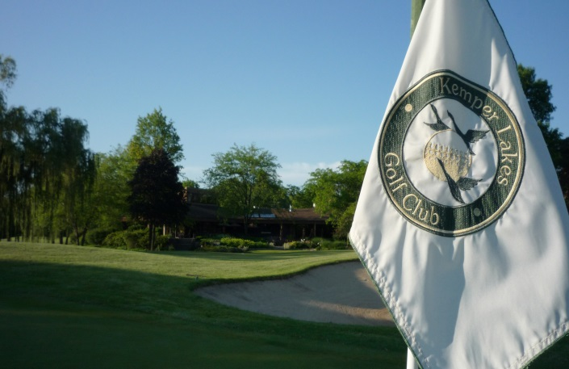
$135 per person (a $300 value)
Package includes:
- Driving Range
- 18 Holes of Golf with Cart
- Box Lunch
- 2 Drink Tickets
- Cocktails and Hors d’oeuvres
- Steak or Fish Dinner - Prize Presentations

Call your friends…Call your neighbors…Get your golf buddies…Treat your clients and
join-in on the fun.

Only 120 spots available & registration ends on Sept. 23rd
Payment and Registration taken at the Village Hall
-----------------------------------------------------------------------------------------------------------------------------------------------------------------------------------------------------

Date: _______ Number of Players:__________ No. Dinners: ____ Beef / Fish ____

Name of Resident:______________________________________________________________

Cell Phone Number:________________________ Email Address:_______________________________________

Names of all Players:____________________________________________________________________________

______________________________________________________________________________________________

______________________________________________________________________________________________
Amount Due:_____________

Complete this form and return it to Village Hall along with payment to complete your registration and reserve your place for this special event (forms w/o payment cannot be honored)

