Volunteer Time and Engagement Report (see images of time report below)
Welcome to LBFE’s new Volunteer Engagement Report. What follows is a step-by-step guide that will walk you through the simple process of submitting your hours and reporting on your elder’s well-being.
If you are volunteering as a Visiting Volunteer, Phone Companion or In-Person Check-in Volunteer, once you enter your volunteer hours, you will be automatically directed to the Elder Visit Report.
▪ Access the volunteer time and engagement report www.littlebrothersmn.org/Volunteer/TimeReport.aspx.
▪ Enter the password: lbfe
▪ Scroll and select your name to enter it from the dropdown menu:
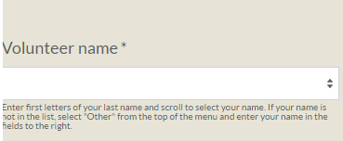
▪ If your name does not appear on the drop-down list move to the next set of name fields and type in your name:
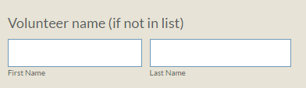
▪ Next, enter the amount of direct-contact time spent with your elder under My time spent with elder
▪ Next, enter any non-direct contact time dedicated to your elder under My time spent without an elder ((include travel time to and from meeting with elder, shopping, etc.)
▪ Select and enter the date of service
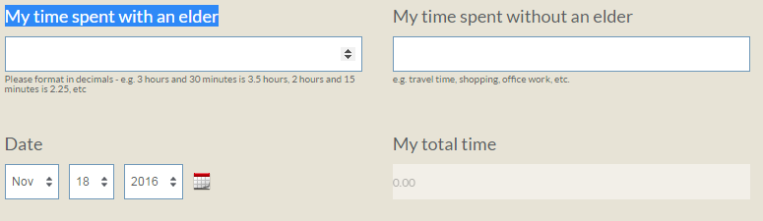

▪ From the drop down menu, under Type of volunteer service, select your volunteer service as appropriate (Visiting Volunteer, Phone Companion, Letter/Card Contact with Elder, Friendship and Flowers, etc.)

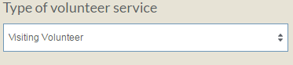

▪ Next, let us know if you provided an elder with a ride, or if you worked with a group of elders:
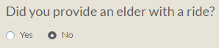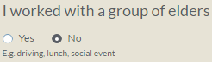

▪ Next, let us know the name of your elder. As with entering your own name above, if the name of your elder is not in the drop-down selection, type in the elder’s name beneath Name of elder.
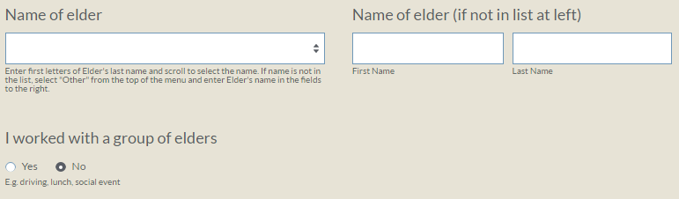

▪ If you have indicated that you are a Visiting Volunteer, Phone Companion or an In-Person-Check-in Volunteer, an Elder Visit Report will appear for you to complete:
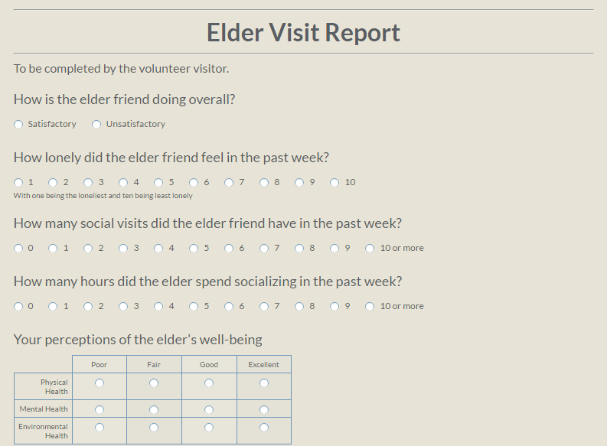
▪ Finally, if you wish to add additional notes about your visit or let us know of an immediate need on yours or your elder’s behalf:
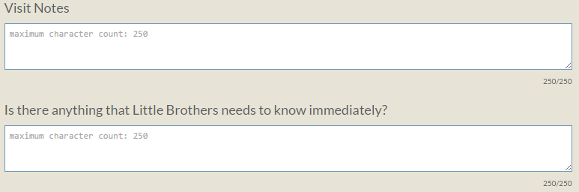
▪ To send your Report, hit submit!

