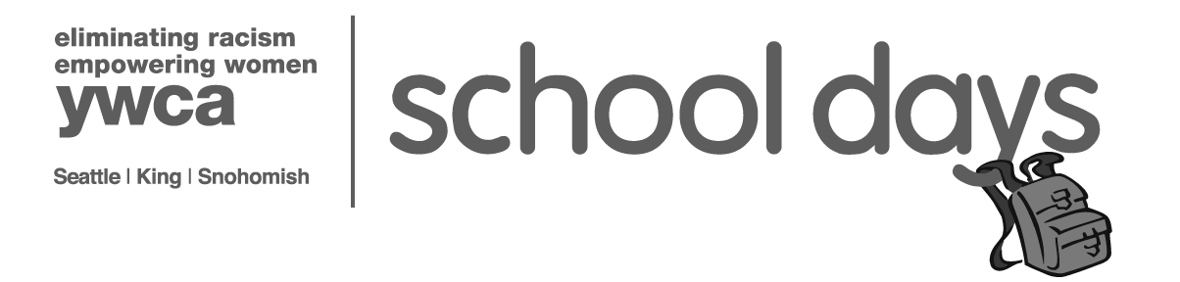

2017 YWCA Backpacks supply list

Kindergarten to 2nd Grade | 3rd to 5th Grade
2 folders | 2 folders
2 spiral notebooks, wide rule | 2 spiral notebooks, wide rule
2 composition notebooks | 2 composition notebooks
8 markers, wide, washable | 8 markers, wide, washable
1 box of crayons/24 count | 1 box of crayons/24 count
12 pencils, #2 | 12 pencils, #2
4 glue sticks | 4 glue sticks
2 erasers, large Pink Pearl | 2 erasers, large Pink Pearl
1 scissors, blunt tip | 1 scissors, pointed tip
1 ruler | 1 ruler
1 pencil sharpener | 1 pencil sharpener
1 highlighter | 1 highlighter
1 box of colored pencils | 1 box of colored pencils
4 dry erase markers | 4 dry erase markers
1 pencil box (approx. 5”x 8”) | 1 fabric pencil case
 | 2 pens
 | 2“ 3-ring binder
 | 5 tab dividers for binder
 | 1 filler paper, wide rule

6th to 12th Grade
2 spiral notebooks, college rule
1 filler paper, college rule
3 composition notebooks
4 pens
1 fabric pencil case
1 glue stick
12 pencils, #2
2 erasers, large Pink Pearl
1 ruler
1 pencil sharpener
6 highlighters
1 box colored pencils
2.5“ 3-ring binder
5 tab dividers for binder
1 USB flash drive
1 scientific calculator

