Creative Writing Corner
Hilton has a Creative Writing Corner to help kids express themselves creatively. Once a month a new topic is shared for the students to write about. All submissions will be displayed for a month in the lobby on the Creative Writing Bulletin Board.
When the submissions are returned, the children will receive a a special prize from the office. If you would prefer your child receive a school supply-type item instead of a treat, send an email to gentangie@yahoo.com
For the younger students, a few words or a picture is appropriate. The older children may want to write a paragraph or two.
Please indicate name, grade, and teacher on the entry, and turn it into your child's teacher.
October Writing Topic:
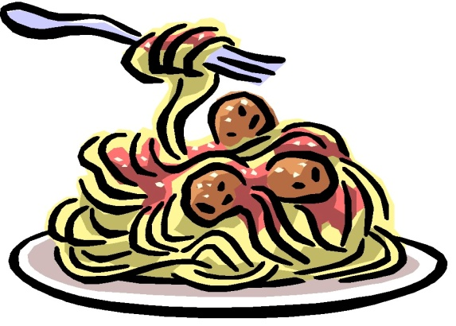
Imagine you had your own restaurant. What would you name it and what would be your most famous dish?
Due Date:
Friday, October 28th

