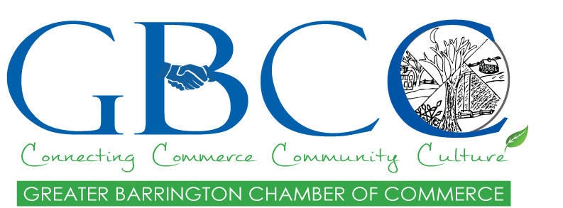
2018 CHAMBER OPEN HOUSE
Have You Ever Wondered What The Chamber Does?
Please Join Us on
Thursday January 18, 2018
Nippo Lake Golf Club
88 Stagecoach Road
Barrington, NH
5-7:30pm
Members from each of our committees will be there to explain what we do and how it can also help your business.
MEMBERSHIP INCENTIVE
Join that evening and receive $25 off your first year’s membership.
When an existing member brings a guest and they join-the member will get a FREE e-blast and go into a drawing for $100 off your own membership.

Appetizers
Cash Bar Available
Trivia Game
Door Prizes
Please RSVP to
administrator@barringtonchamber.org or 603-664-2200

