2017 Kieran May Memorial Golf and Gala Sponsorship Opportunities
Register and pay by March 31st and receive 10% off your sponsorship.
Benefitting the Emerald Coast Children’s Advocacy Center

Gala and Golf Title Sponsor $15,000 only one available
* Logo displayed largest on all marketing pieces * Name listed in all press * Logo on gala invitations (approx. 1000 pieces) * Logo on all social media newsletters * One social media post per month * Recognition as title sponsor on gala and golf programs and at both events * Link to your website * 4 Tee box signs * Three reserved gala tables (30 tickets) * 3 golf teams (12 players) * Opportunity for logo on players gift *

Advocate Sponsor $10,000 only two available
* Logo listed in all marketing pieces and in all social media newsletters * Recognition in gala and golf programs and at both events * Link to your website * Two tee box signs * Two reserved gala tables (20 tickets) * 2 golf teams (8 players) *

Protector Sponsor $6,000 only six available
* Name listed in all social media newsletters * Recognition in gala and golf programs * Link to your website * One tee box sign * One reserved gala table (10 tickets) * One golf team (4 players)

Friend of the Center Sponsor $2,500
* Recognition in gala and golf programs * One tee box sign * 2 golf entries * 4 gala tickets

Angel Sponsor $1,500 only two available
Choice of golf player gift sponsor or golf beverage cart sponsor

Golf activity sponsor $500 only three available
Choice of putting contest, longest drive or closest to the pin sponsor – tee box sign and recognition on golf program

Tee Box Sponsor $100

Gala Table Sponsor (10 tickets) $1,000 only ten available

Golf Team (includes 8 gala tickets) $1600

Gala tickets $125 per person

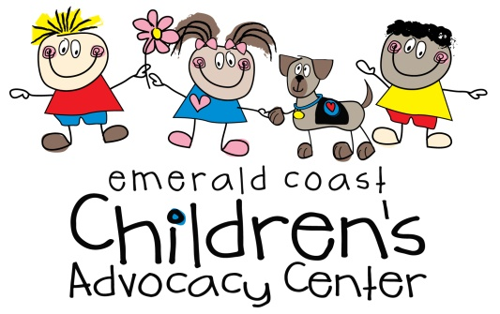
To register or for more information, please contact Kim Henderson at 850-833-9237 x283 or kim@eccac.org. Registration can be mailed to Kim at P.O. Box 1237, Niceville, FL, 32588. Please be sure to include registration form with sponsor level and point of contact with phone and email. Thanks!

