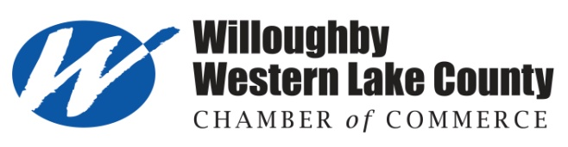
ANNUAL LUNCHEON 2019
DISTINGUISHED AWARDS NOMINATION FORM

The Willoughby Western Lake County Chamber of Commerce will give four awards in the categories of Distinguished Small Business or Industry, Distinguished Large Business or Industry, Distinguished Business Leader/CEO, and Distinguished Showcase Award. We are looking for candidates who go above and beyond what is required in the areas of accomplishments and civic involvement. These candidates are those who have improved the quality of life in the community and/or for others. They are the “silent servers” who often forego personal recognition with the interest of making a commitment to their community and others.

The unique Showcase Award recognizes a business whose property has been a “showcase” for Western Lake County through landscaping, green initiatives, or beautification of the interior and/or exterior of their office/facility.

Please make all nominations legible and limit the reasons to 100 words or less. Be sure to include how long each nominee has been in business & how long they have been a Chamber member (if known). Self nominations are accepted.

Only members of the Willoughby Western Lake County Chamber of Commerce will be considered for this
award--however nominators do not need to be members.

I would like to nominate an outstanding candidate in ONE of the following categories (please check one):
____ Distinguished Small Business or Industry (1-99 employees)
____ Distinguished Large Business or Industry (100 + employees)
____ Distinguished Business Leader/CEO
____ Distinguished Showcase Award

I nominate: __________________________________Name of Business: ____________________________________

Success or Growth with their Business: ______________________________________________________________

_________________________________________________________________________________________________

Community Activities/Involvement: __________________________________________________________________

_________________________________________________________________________________________________

Why is this business/person a great place/person to work/work with? __________________________________

_________________________________________________________________________________________________
(Attach additional documentation as needed)

Submitted by: ___________________________________ Return nomination form by Friday, October 20, 2018

Willoughby Western Lake County Chamber of Commerce
Phone: ________________________________________ 28 Public Square
Willoughby, Ohio 44094
Email: _________________________________________ Email: info@wwlcchamber.com
Fax (440) 942-0586

***Applications will not be held from year to year--previous nominations made will not carry forth to next year

