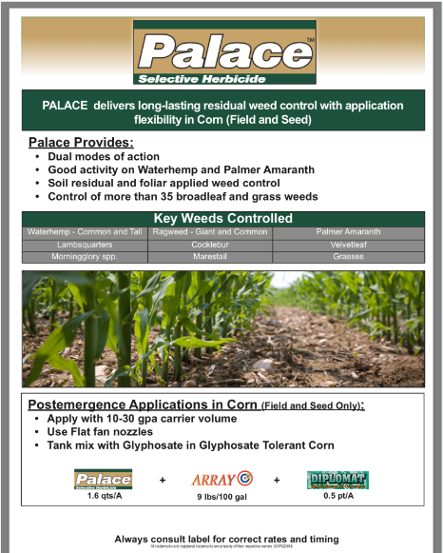

**-UP TO 30” TALL CORN**

**-TANK MIX WITH ATRAZINE IF POSSIBLE**

**+**Buccaneer Plus 1 Qt/ac

***Tradition 93***

***1 Qt/ 100 water***

***1.15-1.6 Qt/ac***