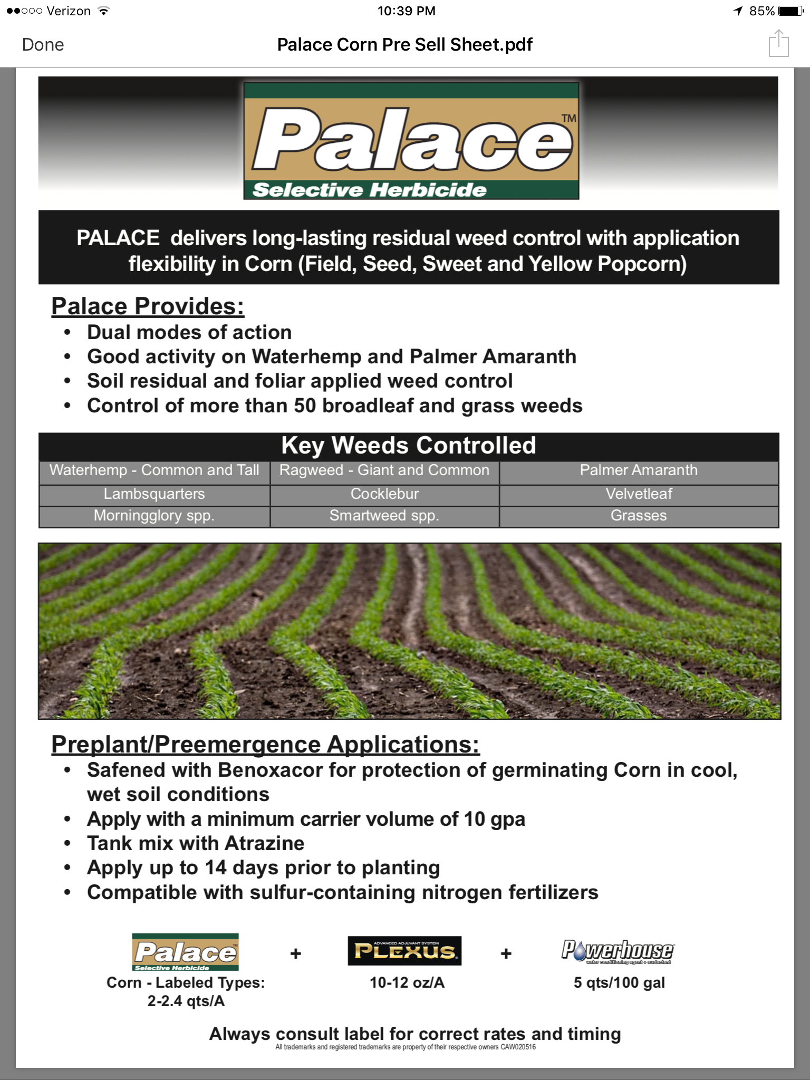

Pre-plant and pre-emerge recommendation sheet