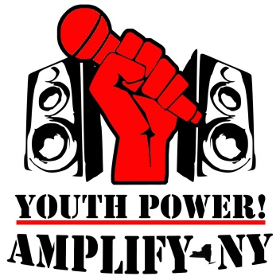

AMPLIFY-NY’s

Western Region

Youth leadership forum
April 4 -7, 2018 The Adam’s Mark Hotel
Buffalo, New York

YOUTH POWER!’s AMPLIFY-NY Initiative is hosting a Youth Leadership Forum (YLF) for young people with disabilities to speak up, build skills, and prepare to take on leadership roles. This peer-run forum brings opportunities to YOUth and gives the next generation of leaders the tools and support they need for success.
The YLF is a safe, youth friendly environment with plenty of fun activities to compliment the wealth of knowledge being learned! This 4-day, 3-night forum is FREE to attend and includes panel presentations, hands-on activities to practice leadership skills, and supported leadership activities. Future leaders do not want to miss this opportunity to build leadership skills, and become empowered with self-confidence and self-determination.
www.YOUTHPOWERNY.org/AMPLIFYNY

- Disability History, Rights, Culture, Pride, Etiquette, and Self-Awareness
- Self-Determination, Self-Advocacy, Peer Advocacy, and Systems Advocacy
- Leadership & Communication Skills
- Financial Literacy
- Adaptive Sports
- Networking & Public Speaking
- Resources to Reach YOUR Goals
- Assistive Technology & Accommodations
- Personal Leadership Plans
- Hands-on Activities & Panel Presentations!
- Evening Activities and More!
The 411:
- It’s a unique opportunity; have the chance to attend as one of 30 young people selected.
- Have fun. This is not your ordinary leadership event!
- Be connected with an experienced advisor to complete a leadership project that interests you.
- This event is FREE if accepted and includes your meals and housing, and transportation assistance.

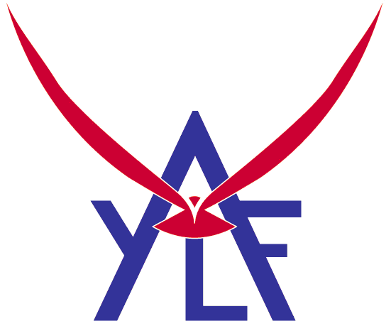
In order to be selected you must:
- Have a developmental or other disability.
- Be in the age range of 14-24 (Youth under 18 must have guardian approval).
- Live in New York State.
- Show demonstrated leadership potential in your application.
- Complete the application and return it by March 11, 2018
Proud member of the National Association of Youth Leadership Forums

@YOUTHPOWERNY | www.YOUTHPOWERNY.org | #AMPLIFYNY
KEEP THIS PAGE – DO NOT RETURN WITH APPLICATION

Thank you for completing this application. Please use the checklist below to make sure your application packet is complete. Incomplete applications will not be considered.

Required Items | Completed
1. Application Form (3 pages)
2. Short answer questions (response to four topics)
3. One letter of Recommendation (or two)
4. Signatures (your own, support person and legal guardian if applicable)

Applications must be received by March 11, 2018.
Applicants will be notified of selection status no later than March 19, 2018.
Please be advised that participants are required to remain for the duration of the event.

If you have any questions about the YLF, please call Elijah Fagan-Solis at 518-432-0333 ext. 19 or email AMPLIFYNY@YOUTHPOWERNY.ORG

MAIL COMPLETED APPLICATIONS TO:

YOUTH POWER!
Attn: AMPLIFY-NY
737 Madison Ave
Albany NY 12208

Email with subject AMPLIFY-NY Western Region YLF 2018 to AMPLIFYNY@YOUTHPOWERNY.org

HOW INDIVIDUALS WILL BE SELECTED

Applications received are reviewed by YOUTH POWER!’s Special Events Planning Group. Special Events will ensure the group selected represents the diversity of disabilities, gender identities, and ethnicities in each region to the best of their ability.

After being selected, students will be asked to complete a confirmation form and provide additional information to the Amplify-NY Leadership Team. All appropriate expenses will be paid by the Youth Leadership Forum, including lodging, food, materials.

AMPLIFY-NY’s Regional Youth Leadership Forums are brought to you by:

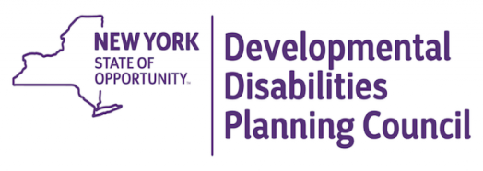

AMPLIFY-NY’s

Western Region

Youth leadership forum

2018 Application

SEND YOUR COMPLETED APPLICATION TO:
Email: with subject AMPLIFY-NY Western Region YLF 2018 AMPLIFYNY@YOUTHPOWERNY.org
Mail: YOUTH POWER! 737 Madison Ave. Albany NY 12208
By March 11, 2018

Section I: Information

Name: ___________________________________________ Today’s Date: ___/____/____

Date of Birth: ___/____/____ Pronoun: ☐ (He/Him) ☐ (She/Her)
☐ Neutral (Such as They/Them): ___________________

E-Mail Address: __________________________________________________________________

Permanent Address: ______________________________________________________________

City: ___________________ State: ________ Zip Code: _________ County: _________________

Phone: ( ) _____________________ Other Phone: ( ) ____________________________

Best times to contact: ☐Morning ☐Afternoon ☐Evening
Do you have regular access to e-mail? We will be sending future communications related to this event through email unless otherwise requested. Yes No

Would you want materials in the future to be in alternative formats?
☐Large Print ☐Text Only ☐Electronic Version ☐Braille ☐None apply

What is your primary language? _____________________________________________________

Other languages you speak fluently? _________________________________________________

Do you know someone who is also applying that you would be comfortable rooming with?
No Yes (provide name) ______________________________________________________

Do you have any food allergies/dietary restrictions? Will you need an accessible room with roll-in shower? (We will collect in depth medical & accommodations information upon acceptance)?
________________________________________________________________________________________________________________________________________________________________

What youth organizations have you been a part of and in what role? ______________________ ________________________________________________________________________________________________________________________________________________________________

We ask the following questions to make sure that the young people we select are diverse in ethnicity, gender and disabilities. The information will not be shared outside of YP! staff, the selection committee and our grant funders.

What best describes your gender identity? ☐Male ☐Female ☐________________________

Which race/ethnic group do you identify with the MOST? (Check one)
☐Black/African American ☐Asian ☐Native Hawaiian/Pacific Islander ☐European/Caucasian ☐Hispanic/Latino ☐Native American/ Alaska Native ☐Other (specify): _____________________

Do you identify as a part of the LGBTQIA+ community? ☐Yes ☐No ☐No, but I’m an Ally

Do you identify as transgender? ☐Yes ☐No

Do you have a disability? Please check all that apply.
☐Developmental/Intellectual ☐Emotional/Behavioral ☐Health ☐Hearing ☐Learning
☐Mobility ☐Visual ☐Other (specify): ______________________________________________

Section II: Short Answer Questions

Please give us detailed answers to all of the following questions. Your answers will be used to assess your readiness to participate in the leadership forum. The more you say, the better we get to know you. Please complete your answers on another sheet of paper and attach it to your application if you are not typing this directly into the document. Your total response to all these questions should not exceed four (4) typed double spaced sheets (one sheet per answer). Important: Answers may be submitted via audio file (tape, disk, wav), if necessary.

- Who are you? – Tell us a little about yourself and share with us an important experience you have had as a young person with a disability.

- Who do you look up to? – tell us about one or two people who have positively influenced your life and why (Families, teaches, counselors, friends, politicians, or celebrities are appropriate examples)

- What are your goals? – Describe any of your current plans/goals you are seeking to accomplish (schooling, career goals, independent living, etc.)

- Why do you want to attend? – tell us why you want to attend this forum and what do you hope to get out of it?

Section III: Letter of Recommendation
Please attach one or two letters of recommendation which describes your demonstrated leadership skills or your leadership potential. This letter should not be from a family member, but from a teacher, counselor, a community representative, co-worker, mentor, youth group leader, etc.

Please list name, position/title, organization and phone number of the person who is providing your recommendation.
________________________________________________________________________________________________________________________________________________________________________________________________________________________________________________
Section IV: Signatures
This application was completed to the best of my ability. All information about myself is truthful and factual to the best of my knowledge. I completed this application on my own and/or with the assistance of the support person identified below.

____________________________________________________ _____________________ Signature of Applicant Date

_____________________________________________________
Printed name of Support Person, if applicable

_____________________________________________________ _____________________
Signature of Support Person, if applicable Date

Youth under 18 will require guardian approval.

I,_______________________________________________, (Legal Guardian’s name) hereby give permission for __________________________________________ (Print youth participant’s name) to attend AMPLIFY-NY’s Western Region Youth Leadership Forum, in Buffalo, New York. I understand that YOUTH POWER! staff and vetted volunteers will be present during this event and that I will need to coordinate with YOUTH POWER! staff regarding transportation to and from the event.

_____________________

Legal Guardian Signature Date

Printed Name

