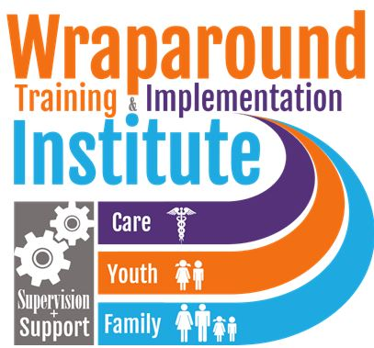
2018 NYS SOC Scholarship Application
SEND YOUR COMPLETED APPLICATION TO:
Email: uyp.scholarships@youthpowerny.org Subject: UYPSOC
Mail: YOUTH POWER! 737 Madison Ave. Albany NY 12208
Fax: 518-434-6478
By June 1, 2018

Applicant Information

Name: ______________________________________________________________________

Gender: ☐ M ☐ F ☐ __________ Pronoun: ___________ Date of Birth: ______________

Mailing Address: ____________________________________________________________________________

____________________________________________________________________________

____________________________________________________________________________

City: _________________________________ State: ___________ Zip Code: ____________

County: _____________________________________________________________________

Home Phone (with area code): __________________________________________________

Cell (with area code): _________________________________________________________

E-mail Address: ______________________________________________________________

Are you involved with any youth groups? ☐ Yes ☐ No

If yes please list the name of the group(s) and your role.

Name: _______________________________________________________________________

Role:

_______________________________________________________________________

What major would you like to declare for UYP? ☐ Peer Advocacy ☐ Systems Advocacy

Choose from the following registration types:
☐ Resident Student (overnight) ☐ Day Student

Do you have regular access to e-mail?  Yes  No
If yes, how often do you access it?  Daily  Weekly  Monthly

Which race/ethnic group do you identify with the MOST? (Check one)
❑ African American ❑ Asian/Pacific Islander ❑ Native American
❑ Hispanic/Latin ❑European/Caucasian ❑ Other _________________________

What service systems have you used in your life? (Check all that apply)
❑ Mental Health ❑ Child Welfare ❑ Criminal Justice ❑ Developmental Disability
❑Addiction Recovery ❑ Special Education ❑ Employment Services ❑ Temporary and Disability Assistance ❑ Other ________________________________________________

Are you currently employed as a Youth Peer Advocate?  Yes  No

If yes please list the name of the organization you work for.

Organization:

_________________________________________________________________________

Short Answer Questions

Please give us detailed answers to all of the following questions. The more you say, the better we get to know you. It is best to attach another sheet of paper if you are not typing this directly into the document.

- What’s one thing you want to change about the systems, organizations or communities you are involved in? Why?

- Why do you want to attend the University of YOUTH POWER! and what do you hope to get out of it?

- Your participation in UYP also means that you are willing to be active in your county’s System of Care. Please tell us what you hope to do to bring more youth voice to your county.

Signatures

This application was completed to the best of my ability. All information about myself is truthful and factual to the best of my knowledge. I completed this application on my own and/or with the assistance of the support person identified below.

Signature of Applicant : ___________________________________________________

Date: ___________________________

Printed name of Support Person, if applicable:

______________________________________________________________________

Signature of Support Person, if applicable:

______________________________________________________________________

Date: ____________________________

Please contact us if you have questions.
Olivia Fried, Social Marketing and Events Coordinator
Phone: 518-949-4338
Email: uyp.scholarships@youthpowerny.org

