

June 23-26, 2018 | Albany, NY

Call for Professors and Activity Leaders:
June 23-26, 2018, YOUTH POWER! will host the fifth annual University of YOUTH POWER! (UYP). UYP is the premiere youth peer leadership conference modeled after a college experience. This conference provides Youth Peer Advocates and change agents the opportunity to build skills and expand their professional network. Young people ages 18 to 30 can register for this for-youth-by-youth social justice conference with a major of Peer Advocacy or Systems Advocacy.

Individuals are not limited to one proposal. We encourage you to consider proposals that address the specific needs of each major or provide advanced and beginner courses to fit the diverse needs of students. Proposals can also include creative and engaging activities for all students to participate in. Proposals are due by Friday, February 23, 2018.

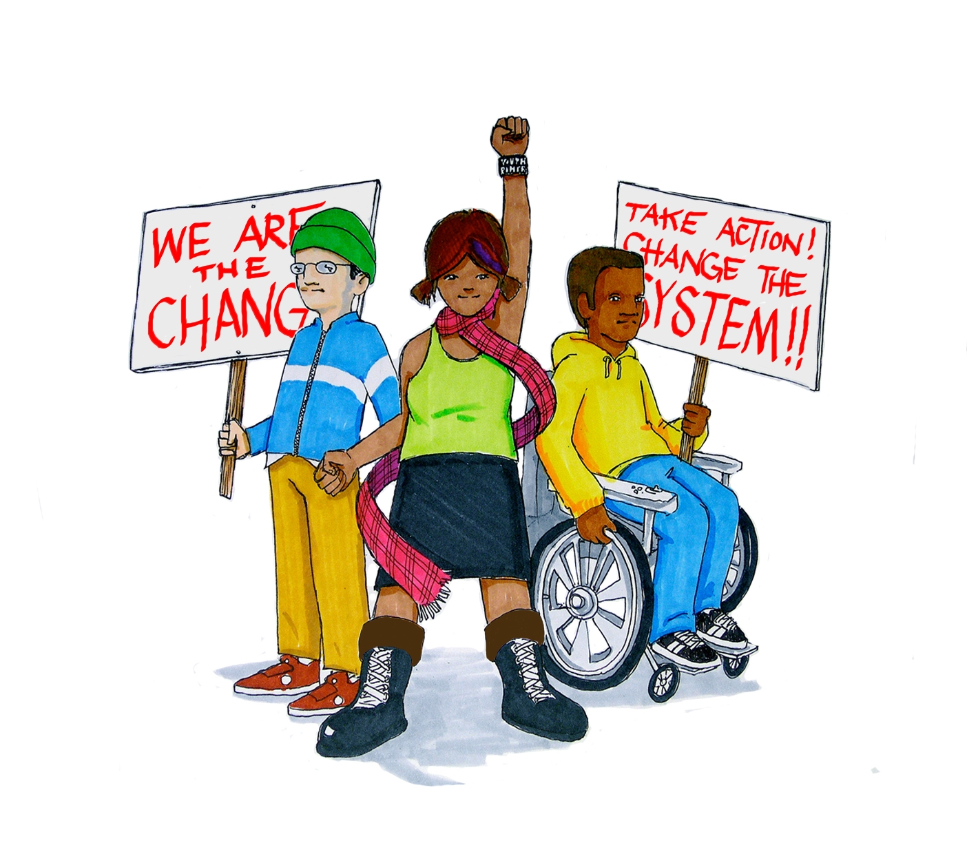
UYP Majors

Systems Advocacy
This major is for young people focused on changing systems and using their voices to influence policies, practices, regulations, and laws.
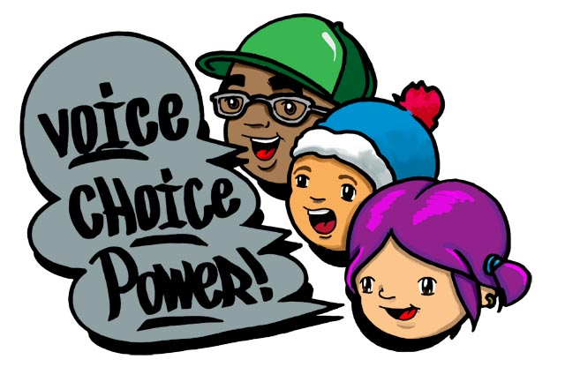
Peer Advocacy
This major is for young people focused on promoting self-advocacy through empowerment and shared lived experience. Youth Peer Advocates, or those interested in becoming one, are encouraged to join this major.

University of YOUTH POWER! Class of 2018:
Please complete the form and email it to uyp.professors@youthpowerny.org
Or Fax it “Attn: YOUTH POWER!” to 518-434-6478 by February 23, 2018.
Presentation topics listed on the following page.
We are seeking presentations for the following topics:
Systems Advocacy Major:

- Systems advocacy skills
- Strengthening anti-stigma and anti-discrimination efforts
- Advocacy campaign development
- Advocacy in the school system
- Building and leading effective teams
- Building a professional network
- Strengthening anti-bullying initiatives
- Campaign for multiple pathways to a diploma
- Civil rights and social justice history
- Conflict resolution: negotiation and compromises
- Creative ways to engage young people in systems advocacy
- Cultural competency: recognizing and addressing systemic problems
- Disability history: universal design and making things accessible
- How to handle difficult conversations
- How to talk to government officials
- Leadership skills
- Legislative advocacy
- Meeting facilitation
- Navigating multiple systems
- Organizing protests, vigils, and rallies
- Public speaking
- Regional, statewide, and national programs, connections, and collaborations
- Self-care in public policy work
- Self-advocacy in the workplace & committees
- Strategic sharing
- Developing trauma informed policies and practice
- Understanding young people’s rights
- Strengthening youth addiction recovery campaigns

Peer Advocacy Major:
Proposals are due Monday, February 6, 2017.
For more information, visit www.YOUTHPOWERNY.org/uyp/ or contact UYP.Professors@youthpowerny.org or 518-432-0333 ext. 31 with questions.

- Youth peer advocacy skills
- Reporting rights and responsibilities
- Addressing stigma & discrimination in the workforce
- Addressing the needs of specific populations
- Building and leading effective teams
- Building a professional network
- Bullying prevention and interventions
- The history of the peer movement
- Communicating with families as a Youth Peer Advocate
- Conflict resolution
- Creating safe & inclusive spaces
- Cultural Competency
- Disability history: universal design and making things accessible
- The effects of language, terminology, and labels
- Effective communication
- Group & meeting facilitation
- Leadership skills
- Multiple Pathways to a Diploma: supporting young people in their journey
- Navigating multiple systems
- Peer support group activities
- Practicing self-care as a Youth Peer Advocate
- Regional, statewide, and national programs, connections, and collaborations
- Self-advocacy in the workforce
- Strategic sharing
- Trauma informed care and techniques
- Understanding young people’s rights
- Youth addiction recovery

Activities for All Majors:
•Artivism • Universally accessible ice breakers, energizers, and activities.
Proposals are due Monday, February 6, 2017.
For more information, visit www.YOUTHPOWERNY.org/uyp/ or contact UYP.Professors@youthpowerny.org or 518-432-0333 ext. 31 with questions.
University of YOUTH POWER!
Class of 2018:
Please complete the form and email it to uyp.professors@youthpowerny.org
Or Fax it “Attn: YOUTH POWER!” to 518-434-6478

Please provide the following information:

Primary Contact: Name as you would like it to appear in the program and complete contact information

Name Title

Organization

Phone Email

Please provide a brief bio for the Primary Presenter: (no more than 200 words)

Additional Presenters: Name as you would like it to appear in the student handbook

Name Title

Name Title

Name Title

Please circle the day(s) and time(s) you would like to present or host an activity.

Saturday | No Classes | Afternoon | No Classes
Sunday | Morning | Afternoon | Evening Activity
Monday | Morning | Afternoon | Evening Activity

Do you have any limitations on when you can teach your course/activity? If so, please describe.

Which major would you categorize your course/activity as? (You Must Select One)
Peer Advocacy Systems Advocacy  Activity for all students

Please provide a title and a brief description of your course/activity to be published in the student handbook.
Title:

Description (maximum 300 words):

Please explain how you will include interactive activities. (Our students want to learn through activities. Classes should not be limited to lecture and discussion):

List at least 3 to 5 things students will learn from this course/activity and take back with them?

Have you presented this material before? If yes, please tell us where and when.

Would you be willing to offer your course more than once or separately for each major?

Our classes are an hour and fifteen minutes. Will you need more than one class period to cover your course content? If yes, how many?

Classrooms will be set up with smart boards or projectors with screens. Will you need additional technology or a special classroom set up? If yes, please describe. (YP! may not be able to accommodate all requests)

If you are leading a full student activity please describe the type of space and set up you will require:

Provide a bio (maximum 250 words) and headshot for the Student Handbook for each presenter:

Please place an X next to the item(s) that describe you.

___Youth Peer Advocate ______ Systems Advocate ___ YP! Member ___ Youth leader

___ Adult Ally ___ Family Advocate ___ Government Employee ___ Not for Profit Employee

___ Community Leader

The Special Events working group will review your description and you will receive a response by March 6, 2018. If you have any questions or need additional information please contact uyp.professors@youthpowerny.org

Visit our website at www.YOUTHPOWERNY.org

