Combined Heat and Power:
Project Development and Related Technologies
September 15, 2016

Bingham Greenebaum Doll Conference Room
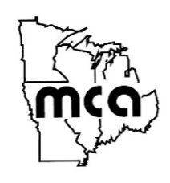
139 N Illinois St, 27th Floor, Indianapolis, IN

Sponsored By:
Institute of Electrical and Electronics Engineers
Midwest Cogeneration Association
Bingham Greenebaum Doll, LLP
Agenda
7:45 AM Registration and Networking
8:30 AM Welcome by Sponsors
8:45 AM Introduction to CHP
Cliff Haefke, Energy Resources Center
9:15 AM Developing a CHP Project
Pete Grills, Bingham Greenebaum Doll
Anees Azzouni, A.S. Azzouni Consultants
9:45 AM Integration and Design of a CHP Project
Dan Miles and Ted Kussow, Applied Engineering Services
10:15 AM Networking Break
10:30 AM CHP Technologies
Chris Cummings, MacAllister Power Systems
11:15 AM Utility Interconnection Requirements
Nancy Connelly, Duke Energy
11:45 AM Optimizing Your CHP System
Kent Koch, Michigan CAT/MacAllister Power Systems
12:00 PM Lunch/Owner’s Perspective
Kyle Robinson, Loftus Robinson
1:00 PM Adjourn
1:30 PM Optional tour of CHP System at The Switch in Fishers, IN

