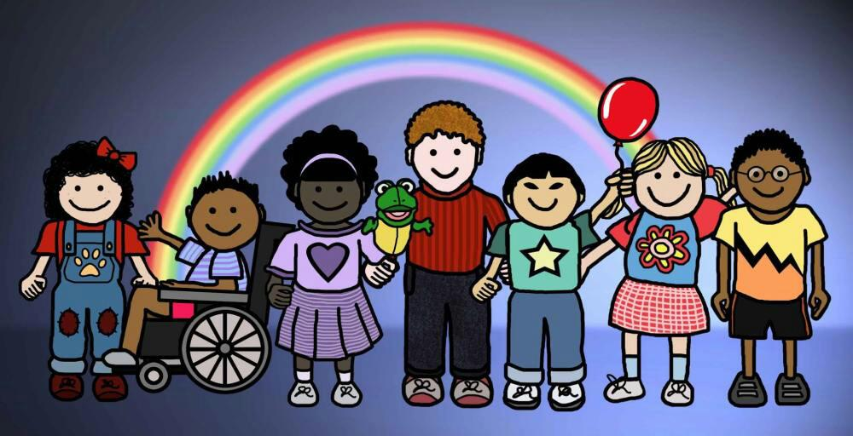

Butler County Special Families Support Network

Who Are We?? A group of families and friends from Butler and surrounding counties, joining together in support of our special needs kiddos…..

What We Do?? Share stories and info, get/give advice, make new friends and allies, have community meetups and scheduled events for the whole family...

Will You Join Us?? Facebook users can join our private group on Facebook for the most up-to-date info! Non-Facebook users, should send us an email at ButlerCountySpecialFamilies@gmail.com to join our mailing list. You may also contact the group admin and fellow special needs parent, Jen Skalley at (513) 915-8059 with any questions!

