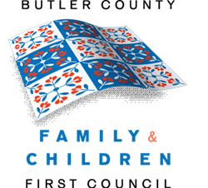
Cross Systems Training Committee
2017 Meeting Dates

1/23/17
2/27/17
3/20/17
4/17/17
5/15/17
6/19/17
7/17/17
8/21/17
9/18/17
10/16/17
11/20/17
12/18/17

All meetings are held at The Center for Family Solutions (CFS) Conference Room
1:30 - 3:00pm

Committee Co- Chairs:
Michael Albrecht, Fairfield City Schools
Chrystal Green, FCFC Family Representative

Contact Lauren Perry, FCFC for questions
(513) 785-6770
perryl@bcesc.org

*Meeting dates are subject to change

