PLEASE JOIN US!
Seminar for self-advocates, parents & family members

Effective legislative advocacy;
writing and meeting your legislators

Supported by:

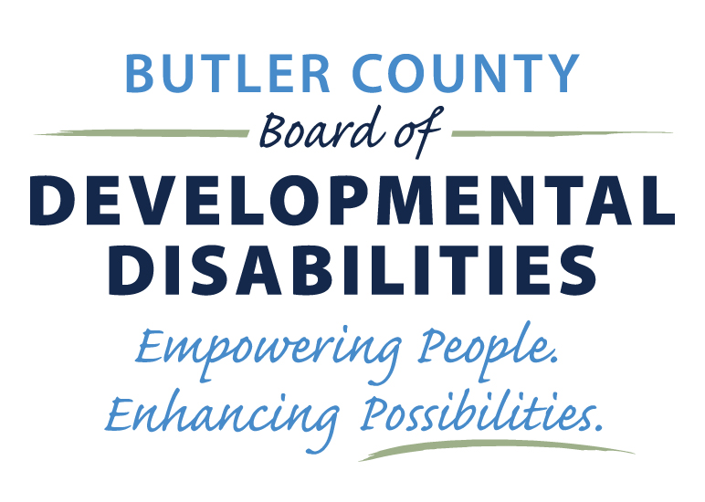

Date
November 17th
Two Sessions: 10:30 a.m. or
7:30 p.m.
Location
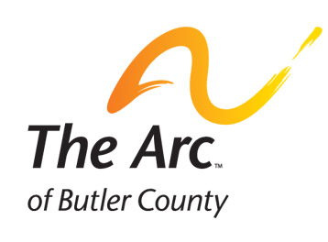
Four Points by Sheraton
7500 Tylers Place Blvd.
West Chester Twp., OH 45069



SMART Grant

Both sessions will include:
Pizza bar, coffee, cookies & drinks
Training Agenda – 90 minutes

A. Introductions and Background – 10 minutes
B. Effective Story Telling - 30 Minutes
C. Putting A Story into Letter - 15 Minutes
D. Telling Story in Effective Meetings - 15 Minutes
E. Examples / Workshop - 20 minutes

