

Volunteer Resource Newsletter
Published June, 2017



Tourism ambassadors needed
The Butler County Visitors Bureau is welcoming new volunteers into its Tourism Ambassador Program. Ideal Tourism Ambassadors possess a passion for tourism and enjoy interacting with the public. They have great interpersonal communication skills, a good knowledge of Butler County and a willingness to help a diverse population of people. They assist the Visitors Bureau at many popular sporting and community events throughout the year, as well as helping at the BCVB office with mailings, etc. Must provide own transportation. Contact Tracy Kocher 513-860-4194 tkocher@gettothebc.com.

Help with June fishing derby and July festival Pyramid Hill Fishing Derby, Saturday, June 17. Enjoy a morning helping kids 12 and under experience a morning of being outdoors fishing. Duties include: set up, assisting with registration, counting and measuring fish and tear down. 9 am to noon. Then be our guests to enjoy the rest of the day at Pyramid Hill. Contact Shaun Higgins at 513-868-8336 or shiggins@pyramidhill.org.
Blues, Brews & BBQ, Saturday, July 15. Blues Bands, BBQ trucks and Craft Beer. Be a part of this festival on the grounds of Pyramid Hill. Help us with traffic control and parking. There will be two shifts between 3 and 9 pm. Then enjoy free admission to the festival. A fun day for all! Contact Shaun Higgins at 513-868-8336 or shiggins@pyramidhill.org.

Step Out Against Heroin And Addiction Sojourner Recovery Services needs 5K Volunteers on June 10. Set up, registration, water stops, etc. at 1430 University Blvd., Hamilton, OH 45011. This is an early morning event. All volunteers are asked to arrive at 6:15am. You will be home by noon. Last year we had over 300 participants. All Volunteers Will Be Provided a T Shirt. Contact Christine Birhanzl, cbirhanzl@sojournerrecovery.org 513.896.3450.



Relay for Life Volunteers Needed June 3
This year the Hamilton, Fairfield and Monroe-Middletown American Cancer Society’s Relay for Life Events have been combined and will be held Saturday, June 3, at noon through 6 am on Sunday, June 4, at The Butler County Fairgrounds (1715 Fairgrove Ave, Hamilton, OH 45011)

Among other things, they are looking for volunteers to help with parking at the fairgrounds. They have designated an area for parking and need some individuals to direct the public in the right direction. Contact Karen Wittmer karen.wittmer@hamilton-oh.gov (513) 844-8050.

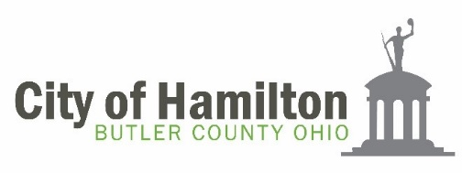

Help at Hamilton Flea, RiversEDGE, Alive After 5
Hamilton Flea - set up and tear down from 8 - 10 am and 4 - 5 pm on June 10, July 8, August 12 and September 9.
RiversEDGE - Putting on wrist bands at the gate from 5:30 - 9:00 pm - June 15, June 23, June 24, July 4, July 13, July 20, July 27, August 24 and August 31.
Alive After 5 - June 1, July 6, August 3, September 7, October 5, November 2 and December 7. Two volunteers for the info booth from 5-7 and 2 from 7-9 each time.
Contact Karen Wittmer karen.wittmer@hamilton-oh.gov (513) 844-8050.


Summer Lunch Program Volunteers Needed You may see a new Food Bus painted by Lakota East and West students, driving about town serving lunch at several Summer Lunch sites. The updated bus is the newest addition to Summer Lunch, a ministry started by local churches and Butler County Success several years ago, which now has developed into a broader partnership between the Faith Alliance, Butler County Success, Lakota Child Nutrition, Mission Possible, and many other concerned church groups, businesses and individuals.
VOLUNTEERS NEEDED - Even though the Food Bus staff will be serving lunch to children, volunteers needed to assist young ones with lunch, monitor lunch and clean up, and offer much needed mentorship to children who are many times left alone all day. Volunteers bring sports equipment or crafts, or even books to read. Sites this year include: Liberty Jr. School, Meadowridge Apartments, Lakota Lakes Apartments, Gettysburg Mobile Home Community, Countryside Mobile Home Community, Deer Run Apartments and Princeton Village Mobile Home Community. All but Gettysburg and Deer Run, are in need of volunteers.
VOLUNTEER: http://www.signupgenius.com/tabs/23674D80EA2C8E8C24-countryside. Currently, Lakota has approximately 20 % of their students or 3,400, who qualify for free and reduced school lunch.
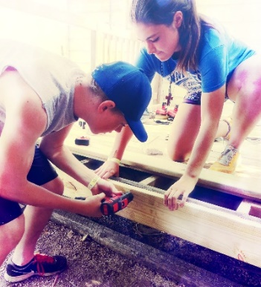
SELF’s Home Repair Summer Blitz Weeks Volunteer Opportunities for Middletown project:
Refreshment & Welcome Day Donations now through July 1 - Help SELF gather treats and trinkets for our 100+ visiting campers (i.e. pens/pencils, postcards, sunscreen, toiletries, etc.). We will also be securing food donations from local restaurants for a “Taste of Middletown” Welcome Dinner and need snacks to feed hungry teens (most requested items include: candy, granola bars, cookies, individual bags of chips, soda and sport drinks).
Host a “Tools of Change” Supply & Gift Card Drive NOW through July 1 - Find out how to host a building material supply drive or collect gift cards to home improvements stores at your school, community group, professional organization or place of worship. Contact Debbie at ddepew@selfhelps.org or 513-820-5019 to learn about the most needed items and to receive an information packet with tips on how to organize a collection!
Group Workcamp Welcome Day Sign-in July 9 - Distribute welcome day treats and answer questions campers may have about Middletown. Help youth groups unload their vehicles and set up camp at Middletown High School.
Adopt-a-Site: Afternoon Treats during Blitz Week, 1-3pm (July 11 & 13) - Great opportunity for groups, businesses or individuals to provide cold treats to campers at 50+ worksites on either Tuesday and/or Thursday from 1 -3pm. Soda and sport drinks donations are greatly appreciated!
Construction Project Advisors During Blitz Week 9am-3pm - Volunteers will oversee work being done at sites. Project advisors will travel to a variety of sites each day to answer questions and provide advice on how to best complete work and troubleshoot any construction issues that may arise.
To learn more about any aspect of this home repair effort contact Rebecca Palen rpalen@selfhelps.org 513-820-5010.

Volunteers for Programs and Special Events

MetroParks Mojo Triathlon - Sunday, June 18, from 7:00 a.m. - 12:00 p.m. at Voice of America MetroPark, 7850 VOA Park Drive, West Chester OH 45069. Adult, teen volunteers are needed for packet stuffing prior to the event as well as the day of the event. For more information on volunteer opportunities please visit www.signupgenius.com/go/10c084ca9a823a6fd0-voatriathlon.

Hump Day Concerts – Wednesdays through August 16, from 7:00 - 9:00 p.m. at Voice of America MetroPark, 7850 VOA Park Drive, West Chester OH 45069. Adult and teen volunteers needed to help with various tasks during concerts. Contact Sara Schapman at sschapman@YourMetroParks.net

Crazy Cardboard Regatta - Friday, July 14, from 9:00 a.m. to Noon and Saturday, July 15, from 11:00 a.m. - 3:00 p.m. at VOA. Adult and teen volunteers are needed on Friday, July 14, to help prepare for the event as well as the day of. For more information on volunteer opportunities please visit: www.form.jotform.us/70934841467161

Welcome Center - Voice of America MetroPark (weekends) at Voice of America MetroPark, Ronald Reagan Lodge, 7850 VOA Park Drive, West Chester OH 45069. Volunteers are needed at the Welcome Center at Voice of America MetroPark. Welcome park customer/owners with a smile, provide information about programs and the parks. Training provided. Contact Claudia Whitacre cwhitacre@YourMetroParks.net

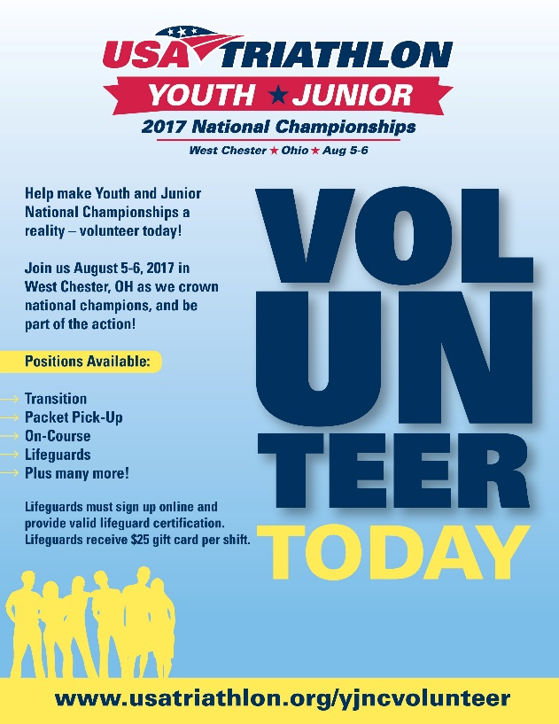

USA Triathlon’s Youth + Junior National
USA Triathlon is seeking volunteers for their Junior + Youth National Championships at Voice of America MetroPark in West Chester. Volunteer shifts run from Wednesday, August 2, through Sunday, August 6. Lifeguards are also needed and must sign up online and submit a valid lifeguard certification in exchange for $25 gift card/per shift. Volunteer and lifeguard sign ups: www.usatriathlon.org/yjncvolunteer.



Hamilton NightGlow Marathon & Half Marathon
The Hamilton NightGlow Marathon & Half Marathon will be taking place in Hamilton on September 2, with the start/finish line at the Fitton Center for Creative Arts. The event will include a full marathon, marathon relay, half marathon and 10K. Volunteer shifts include finish line support, water stations, packet pickup and more. Contact info@hamiltonnightglow.com for further information and to sign up.

Help needed at 5k walk in Blue Ash
MADD Southwest Ohio is looking for volunteers from Butler County to help set-up and tear down the day of their Walk Like MADD 5k walk on Saturday, Sept. 30, at Summit Park in Blue Ash. Contact Ariana Bowen, Volunteer Resources Specialist, Ariana.Bowen@madd.org or 614)885-6233 ext. 3956.
walklikemadd.org/greatercincinnati.

What does Mothers Against Drunk Driving Do?
• Provides emotional support and assistance with medical and legal struggles that follow a drunk driving crash.
• Conducts awareness and research-based prevention programs to stop drunk driving and underage drinking such as our Victim Impact Panel program which allows offenders to see their offense from the eyes of the victims and the impact that their actions can have on others.
• Supports all the heroes in law enforcement who work to keep our roads safe. One of the ways we do this is through our Death Notification training which has been designed for those whose line of work requires them to regularly conduct death notifications to the victim’s loved ones

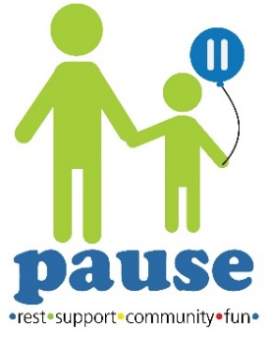

Be a buddy at Game Night!
This summer Pause is partnering with the Board of Developmental Disabilities to host their monthly Game Nights held at the Janet Clemmons Center. Game Nights are a fun way for teens with disabilities to learn social skills through hands-on learning (interacting and playing with others). This fun volunteer opportunity is open to everyone 14+ and is great opportunity for parents to volunteer with their kids! The benefits to the families are immeasurable and we can’t do it without our volunteers! Register now on the Pause website: http://www.butlerfcfc.org/page/volunteer-pause


Volunteers, bands needed for Music Festival Saturday, September 30, will mark the 2nd Annual Faith Alliance Music Festival – Sing Out Against Poverty at The Square at Union Centre. Last year more than $4,000 was raised to support our hunger and education programs benefiting at-risk, low-income families and children. We are searching for individuals and praise band members in the West Chester and Liberty Township area who have a passion for service and would like to lend their talents to coordinate or play at this Christian event. If you or your church has interest, contact Sue at smahlock@thefaithalliance.org to find out more. The first committee meeting will held early May.


Volunteer openings in our area
JustServe is a free website that matches faith, nonprofit, community and governmental organizations that need volunteers with volunteers willing to help. It is an easy way for volunteers to search for opportunities that resonate with their interests. For information about projects in our area visit: www.justserve.org and enter your zip code. It is that simple!

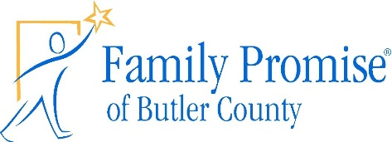

Local Shelter in search of weekend volunteers
Family Promise of Butler County is a 24/7/365 Homeless Shelter program that serves homeless families in Butler County. Help is needed at our Day Center, located in downtown Hamilton, from fun-loving volunteers (and their children) to serve current FP families.

Service opportunities at the Day Center range from hosting a children’s crafts and activities time to teaching FP Core Classes; including: Financial Literacy, Tenancy, Wellness and Job Track.
Interested? Contact Chris Kramer at 513-444-2033 or ckramer@familypromisebutlercounty.com.

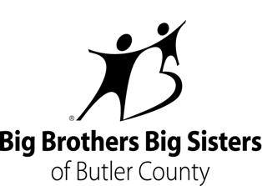

Mentors needed!
Volunteering just a few hours a month with a young person can start something amazing. Our kids say their Big Brothers/Sisters have helped give them hope and changed their view of what they thought was possible for their future. There are many flexible ways to volunteer including community-based mentoring, after-school programs and lunch buddies. For more information on getting involved, call us at 513-867-1227 or visit www.bbbsbutler.org.

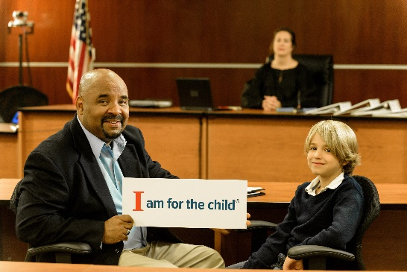

PARACHUTE: CASA Needs Community Volunteers
PARACHUTE: Butler County CASA recruits and trains community volunteers who advocate for abused and neglected children. CASA volunteers safeguard the interests of Butler County’s most vulnerable children - children whose situations are so threatening, that they are referred to the protective jurisdiction of the courts. Reports of child abuse, especially related to parental drug use, have escalated over the past several years and hundreds of abused and neglected children in Butler County find themselves in foster care and family court systems each year. The average child will spend nearly 2 years in foster care and may change homes 3 times before permanent placement is determined. PARACHUTE trains community volunteers who help abused and neglected children find safe, permanent homes. One year of CASA advocacy cost less than one month of foster care. CASA programs change lives and give hope for a brighter future. A child with a CASA volunteer is half as likely to re-enter the foster care system and more likely to succeed in school and receive services to heal from their trauma than children without a CASA volunteer. PARACHUTE is in need of community volunteers to become a part of the solution today! To find out more about CASA volunteer training - call 513.867.5010, email casa@parachutecasa.org or go to www.parachutecasa.org. The next CASA volunteer training will be scheduled for September 2017.



Looking for summer volunteers Abilities First is looking for summer volunteers for their Summer Therapy Program which consists of a variety of classes for different ages, days and times. This summer program runs May 30-August 18. Volunteers would assist teachers and/or therapists in the classroom as needed. Call Pam Roark Gibbs today! Pam can be reached at 513-423-9496. www.abilitiesfirst.org We guarantee your life will be impacted!


Hamilton, Fairfield, Oxford volunteers sought The First Tee of Greater Miami Valley needs volunteers at HAMILTON/FAIRFIELD (Miles of Golf, Potter’s Park Golf Course, Twin Run Golf Course); OXFORD (Indian Ridge Golf Club).
Minimum one day a week for a 3- or 4- week session. Contact Wendy Mockabee | Director of Outreach & Administration wmockabee@thefirstteegmv.org | (937) 432-9600 ext. 3.
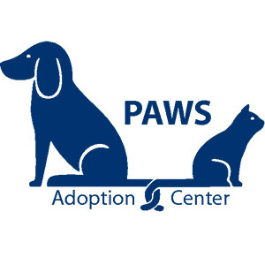

Festival season volunteers needed
The PAWS Mobile Team is gearing up for Festival Season! PAWS attends local festivals, fairs and schools to promote responsible pet ownership and adoption of our animals. Our Mobile Team has so much fun and the animals always benefit from the social time and exposure! Come get some fresh air with our pups! If you're willing to work for snuggles, call us! 513.539.7297.



Assist victims of domestic violence
One in 3 women will experience domestic violence in her lifetime. Make a difference - volunteer with The Center for Family Solutions. Volunteer victim advocates assist victims of domestic violence with applying for Civil Protection Orders (CPO); provide crisis intervention services and emotion support; accompany victims to court for CPO hearings; assist victims with court preparation, safety planning and resource referrals. All victim advocate volunteers will complete a comprehensive 40-hour training program that includes classroom instruction, online learning and direct observation / shadowing. No prior experience required! Contact Erin: cfs.erinf@gmail.com or 513-896-2350. www.centerforfamilysolutions.org.



Respond to hospital calls in Butler County
We are looking for volunteers to serve survivors of sexual assault! Volunteers must be over 18, attend our 40 hour training and then sign up for a minimum of 2 on call shifts per month. Volunteers will be partnered and respond to hospital calls in Butler County if someone has been sexually assaulted and go empower, support and provide resources for the survivor. Contact Staff.whw@gmail.com for more information.



Volunteers needed for Summer Programs
Hamilton Living Water Ministry, Inc. (HLWM) is a grassroots, non-profit organization serving some of Hamilton’s neediest youth and families since 1999. We offer year-round educational and recreational programs to hundreds of children free of charge and have become a safe haven for youth.
Are you, or a small group looking for a volunteering opportunity? We are gearing up for our summer programs which run June 5th – July 27th. Volunteers are needed to help make our programs successful. We love to have volunteers share their talents and skills with our children (grades K-6) and teens (grades 7-12) by reading a book, review spelling words, color or make a craft or be an extra pair of eyes to support our staff and help to show the kids love and kindness. How about filling up water balloons, gardening and weeding or helping in the office with filing, copying and mailings, sorting donations. Come and volunteer one day or as much as your time allows!
Not sure how to help, visit our website at www.hamilton-living-water-ministry.org or please contact Pam at 513-894-9892 or email p.raines-bowers@fuse.net. We also need donations of basic items and materials for crafts if there are those who cannot volunteer but have resources.
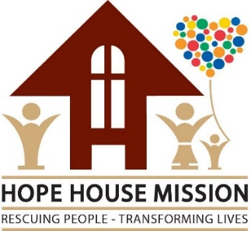
Help serve meals at Hope House Mission Every day, Hope House Mission, Middletown, serves more than 160 hot meals to homeless and hungry guests. Often, a meal served with kindness is the first step on the road to recovery for hurting men, women, and children we serve. It’s more than a meal. It’s hope. We are in need of individuals and groups to assist with serving lunch or dinner, Monday through Saturday, at our men’s or women/children’s shelters. Volunteers can provide and serve a meal (for up to 50 people) or simply help serve meals our cook has prepared. In the spring and summer we are also in need of volunteers who can mow the lawn at our women/children’s shelter. Together, we can break the cycle of poverty and despair, one life at a time. Visit our website hhmission.org to get connected or contact our Volunteer Coordinator at lfields@hhmission.org.



Help at clinic or in food pantry
Want to make a difference in someone’s life, meet new friends and give back to your community? If so then please consider bringing your skills and interests to Mercy Health St. Raphael.

You can volunteer according to your personal schedule, morning or afternoon and depending on your qualifications choose your role!

We interview all applicants to assess interests and skills. We will make every effort to make the appropriate match between the volunteer and the area of need.

Opportunities are available in the clinic and our Choice Food Pantry. Food Pantry Assistants, Lunch Window Attendant, Stocking shelves, Donation Assistants, Volunteer Nurses, Volunteer Physicians, Telephone-Patient Follow-up, Intake Screening, Special Projects. Find out if being a Volunteer at Mercy Health is the right fit for you. Contact Volunteer Services at 513-981-4211 or bgemmons@mercy.com.

Volunteer help is always needed Animal lovers needed for walks and cuddles! Animal Friends Humane Society is looking for caring individuals 16yrs+ who would like to spend a few hours a week playing with and caring for shelter animals. There is no set schedule required and volunteers who have completed orientation can come anytime during open shelter hours, (M,T,F,Sa,Su 11 am to 4:30 pm & W, Th 1 pm-7 pm). Contact volunteer connection 513-867-5727 (main). http://www.animalfriendshs.org/ The next volunteer orientation is Saturday, June 17.


Sort clothing on Saturday mornings Rethreads, a free clothing store in Fairfield staffed solely by volunteers, needs help sorting clothing every Saturday from 10 AM to noon. Rethreads is located at 1425 Nilles Road, Fairfield, OH 45014 in the old Fairfield Church of the Nazarene building. Clothing is free to clients on four days each year (one for each season). Quarterly giveaways typically draw between 200 and 300 clients. Rethreads can arrange to have groups volunteer at other times. Contact Fairfield Church of the Nazarene (513) 549-6394 or Michael Albrecht (michaelalbrecht@gmail.com).

Guardians and ‘Friendly Visitors’ needed
Many of Butler and Warren County’s most vulnerable elderly, mentally ill and developmentally disabled residents have experienced improved lives thanks to the advocacy of court appointed guardians from LifeSpan. LifeSpan was the first organization to offer a guardianship programs in Butler County and remains the only one serving both elderly and those with mental illness or developmental disabilities.

LifeSpan Guardians are appointed by the Probate Court to make decisions for their persons under Guardianship relating to their health care, living arrangement or safety issues. Persons Guardianship are individuals who have no immediate family able to or willing to help them or they have limitations that impair their ability to make competent decisions. They typically live in nursing homes, group homes, or in other supported living environments. Many times, our Guardian is the only person who visits outside of medical professional or caregivers.

LifeSpan is always in need of compassionate Volunteer Guardians or Friendly Visitors as each year the Guardianship programs sees an increase in referrals. This your chance to help those whom may have nowhere to turn. Volunteers must be at least 18 years old and will ongoing training.

Volunteers develop a personal relationship, oversee care, advocate, or just be a friend with individuals under Guardianship. Contact Angelic Frazier- Volunteer Guardian
Coordinator 513-785- 4189 or fraziera@lifespanohio.org. For more information on LifeSpan www.lifespanohio.org


Student and community volunteers welcome
Intergenerational art program for people with dementia is in need of volunteers. Training is required. We welcome​ high school students, home school students, college students or community volunteers. (College credit and post-secondary credit is available). See our website for more information: www.ScrippsOMA.org or call Beth Rohrbaugh at 513-529-7172.



Historical Society seeks volunteer help BCHS is looking for volunteers in a number of different areas. Receptionists – greet guests, light office work; Tour guides – provide tours of the Butler County Historical Society to visitors (will train); Data entry – Assist with the inventory and collection of the Butler County Historical Society. All hours are subject to the availability of the volunteer. We are open Tuesday-Friday 9-4 and Saturday 9-2. If you are interested, please contact Kathy Creighton at 513‐896‐9930 or bcomuseum@fuse.net.



Peer Partner volunteers needed
Peer Partner volunteers: Butler County Community Wraparound (through Family and Children First Council) is adding additional support to our process in the form of Peer Partners. These individuals will be partnering with the youth on Wraparound teams to help empower them to ensure voice is being heard at meetings, as well as help them navigate through the many systems of care. We are currently looking for young adults (over the age of 18) with lived experience (such as involvement with juvenile justice, mental health, children services, substance abuse, developmental disabilities or special education) to partner as volunteers (stipend for attending meetings and mileage reimbursement will be included). If you are eager to learn and grow and help other youth who are struggling to see that they are supported, this may be a good fit! (One year commitment if possible. Hours per week vary.)

Contact Julie Caito, LSW, 513-594-1007, Caitoj@bcesc.org, Butler County Educational Service Center, 400 N. Erie Blvd. Suite A. Hamilton, OH 45011.


Volunteers needed in Butler County Volunteers needed to provide companionship for lonely hospice patients and family members. Volunteers visit individuals in nursing homes, assisted living facilities and patient’s private homes. Crossroads Hospice cares for patients in 7 surrounding counties and we have a need for volunteers in Butler County. Activities may include reading, listening, sitting and talking, playing board games, crafts, singing, sharing music, or other interests. A smile, a caring attitude and a compassionate heart is all that is needed to touch lives and make a difference... the life you touch may be your own.
Volunteers must be at least 16 years of age and have a valid driver’s license. Volunteer interview, training, TB test and background check is required (all cost covered by Crossroads). Volunteering can be flexible. Contact Gretchen Eagle Gretchen.Eagle@crossroadshospice.com. (513)786-3752.


The Caring Craftsmen could use you
We do home repair, accessibility modification and general craftsmen projects for people with developmental disabilities and/or their families. We are an all-volunteer group and our projects are paid for through donations. We do our projects at no cost to families. We have site leaders that have expertise in what the project entails. Site leaders help volunteers learn the craft at hand. If you are a seasoned craftsmen or someone that would enjoy learning a new skill while helping others contact Dave Glock Jr. (937)304-5774 or caringcraftsmen@gmail.com

This list compiled as a service of:

Community
Volunteer Force

Check for updates at:
Facebook.com/communityvoulunteerforce

Questions: Dan Schlosser at volunteerfinder@yahoo.com

