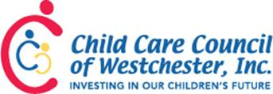

SAVE THE DATE
2017 School Age Conference
Saturday, October 21, 2017

8:00am to 1:05pm
Peas & Karrots Child Care Center, Ossining, NY
Whether you are a director or an assistant teacher, brand new or veteran, there's something for you at the 2017 School Age Conference.

Sponsored by
the Child Care Council of Westchester and the School Age Directors Network

Brochure & Registration Information will be available in August.

