Walk to fight youth drug use/abuse/addiction
Red Ribbon Week
October 14, 2017 10am
Tibbetts Brook Park, Yonkers, NY

River Towns Young Marines
Join our worldwide team to combat the youth epidemic of use/access to harmful drugs and substances.
Stand with us and support our efforts.
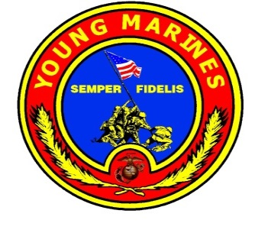
www.youngmarinesrivertowns.org
Interested? Email:LLC1@westchestergov.com

Sponsorship Opportunities
Title Sponsor $2,500
Gold Sponsor $1,000
Silver Sponsor $500
Bronze sponsor $250
Please sponsor today to help Walk to Fight Youth Drug use/abuse/addiction
For additional information/questions, please call Lu Caldara at 914-941-2118 or
Email: LLC1@westchestergov.com

⃝ I am unable to sponsor “Walk to Fight Youth Drug use/abuse/addiction” but wish to show my support with a tax deductible donation of $_________
⃝ Please charge my credit card # __________________________________________
Exp Date _____________ Security Code______ Name on Card______________________
⃝ Attached is a check payable to Young Marines River Towns.

Company / Individual Name: _______________________________________________
Company Address : _______________________________________________________
City: _______________________________ State: _____ ZIP: _____________________
Tel: ________________________________ Email: ______________________________

Thank you for your considerations,
Lu Caldara
Young Marines River Towns
PO Box 2006
Ossining, NY 10562
www.youngmarinesrivertowns.org

