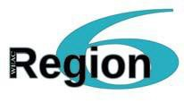

“I’m In” Recruitment Incentive

Excited to help Region 6 grow the power of its membership? For every new member you recruit for Region 6 between August 29, 2016 and November 30, 2016, we will provide you with a $50.00 incentive bonus.

Here are the details:

- To be eligible for the $50.00, you must be a WEAC Region 6 member in good standing.
- The new member you recruit must submit a completed, signed membership form to WEAC Region 6 by November 30, 2016.
- To earn your $50.00 incentives, you must complete the WEAC Region “I’m In” Recruitment Incentive Compensation Claim Form. The claim form must be filled out completely and received by WEAC Region 6 by December 15, 2016, to be eligible for incentive payments.
- Send all completed materials to WEAC Region 6, P.O. Box 8003, Madison, WI 53708.
- Questions, contact your Region 6 Director or call us directly at 1-800-397-2287.

