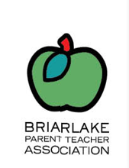
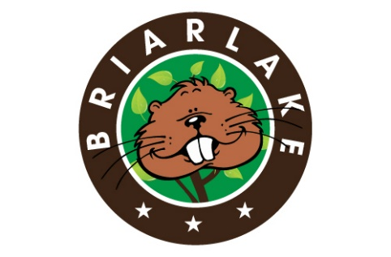
BRIARLAKE
BEAVER BOOST

The Beaver Boost is the PTA’s annual fundraising effort.
The suggested donation is $125. Whether you donate $1 or $125, we would like for each family and teacher at Briarlake to feel they are part of making Briarlake a better school. 100% of the money raised stays with the school.
The Boost supports the following activities for the 2016-2017 school year:
- Gifted certification for teachers, Teacher training, Staff appreciation
- Classroom Start-Up Funds
- Supplies for Art, Music, School Nurse, Special Education, Media Center
- Campus Beautification, Volunteer Coordination, Communications
- Academic & Cultural Enrichment: Lego & Big Thinkers STEM days, visiting artists and cultural assemblies, academic bowls/teams/competitions, Odyssey of the Mind Team
- Family Enrichment: International Night, Ice Cream Social, Family Service Night, Storytelling Night & Book Fair, Family Picnic, Walk & Bike to School Days, Beaver 5K & Fun Run, Field Day
BRIARLAKE BEAVER BOOST DONATION FORM
To donate by check, please complete this form and make checks payable to Briarlake Elementary PTA and write “Beaver Boost” in the memo line. Your donation is tax-deductible (tax ID # 58-6072359). Donations are due by October 22, 2016.
Please cut the bottom of this form and put it in an envelope with cash/check in the PTA box in the office. OR To donate securely online, use https://secure.affinipay.com/pages/briarlake-pta/payments
Date: __________________ Check number: ____________ Donation amount: ________________
Name of Donor: _______________________________________________________________________
Student’s name(s), grade and teacher: _____________________________________________________

