CDC’s Topic of the Week Promotional Toolkit

Moms-To-Be: Protect Your Pregnancy from Zika!
The Best Way to Protect Your Baby is to Protect Yourself
August 22-26, 2016

This toolkit offers social media messaging, tools, and resources for your agency to use to promote CDC’s Topic of the Week for August 22-26, 2016: How to Protect Your Pregnancy from Zika. This week’s topic focuses on encouraging pregnant women to take steps to prevent infection with viruses spread by mosquitoes, like Zika. It is primarily intended for agencies in the continental United States but also can be used by agencies in US territories.
Audience: Pregnant women who live in or traveled to areas with Zika, and their sex partners who live in or traveled to areas with Zika

Contents
Key Messages 2
Sample Social Media 3
Sample Newsletter Content 4
Graphics 6
Resource List 8

Key Messages

- Zika virus infection during pregnancy can cause microcephaly and other severe fetal brain defects. Zika also has been linked with other problems in infants, including eye defects, hearing loss, and impaired growth.
- Because Zika infection is a cause of microcephaly, pregnant women should strictly follow steps to prevent mosquito bites and to protect against sexual transmission.
- Pregnant women can take the following steps to prevent mosquito bites.
  - Wear long-sleeved shirts and long pants.
  - Stay in places with air conditioning and window and door screens to keep mosquitoes outside.
  - Use Environmental Protection Agency (EPA)-registered insect repellents. When used as directed, these insect repellents are proven safe and effective even for pregnant and breastfeeding women.
  - Remove or stay away from areas where mosquitoes lay eggs, such as containers with standing water.
- Pregnant women can take the following steps to prevent getting Zika through sex.
  - If a pregnant woman has a sex partner who lives in or traveled to an area with Zika, they should use a condom or other barrier every time they have sex or not have sex during the pregnancy. To be effective, condoms must be used correctly from start to finish, every time during sex. This includes vaginal, anal, and oral sex and the sharing of sex toys.
    - Barriers that prevent passing Zika through sex include male and female condoms and dental dams.
      - Dental dams are latex or polyurethane sheets used between the mouth and vagina or anus during oral sex.
  - If a pregnant woman is concerned that her partner(s) may have or had Zika virus infection, she should talk to her doctor about
    - Whether her partner had any Zika-like symptoms
    - Her partner’s travel history, including time spent in an area with Zika, and whether or not her partner took steps to prevent getting mosquito bites
    - If they had sex without a condom or other barrier protection since her partner’s return
- CDC recommends special precautions for pregnant women. Women who are pregnant should not travel to any area with Zika.
  - Pregnant women who must travel to an area with Zika should talk to their doctor first and strictly follow steps to prevent mosquito bites during the trip.
- Pregnant women should talk to their doctors if they or their sex partners recently traveled to an area with Zika, even if they don’t feel sick.
- Pregnant women who get Zika can have a baby with birth defects even if they don’t have symptoms. They should talk to their doctor if they are worried they might have had Zika.
- Pregnant women who are worried they might have Zika should talk to their doctor about recent travel and symptoms of Zika they have experienced, such as fever, rash, joint pain, or red eyes.
Sample Social Media

Facebook Posts

- Moms-to-be: Protect your pregnancy from #Zika! The best way to protect your baby is to protect yourself. Check out our prevention tips: https://www.cdc.gov/zika/prevention/index.html
- #Zika infection during pregnancy can cause birth defects. The best way to protect your baby is to protect yourself. Check out our prevention tips: https://www.cdc.gov/zika/prevention/index.html
- Moms-to-be: Protect yourself from #Zika during pregnancy. Take steps to prevent mosquito bites, plan for travel, and protect yourself during sex. https://www.cdc.gov/zika/prevention/protect-yourself-and-others.html
- #Zika infection during pregnancy can cause a serious birth defect called microcephaly. Pregnant women can take steps to protect their pregnancy from Zika. https://www.cdc.gov/zika/prevention/index.html
- #Zika infection during pregnancy can cause a serious birth defect called microcephaly. Pregnant women and their partners can take steps to protect the pregnancy during sex. https://www.cdc.gov/zika/prevention/protect-yourself-during-sex.html
- #Zika infection during pregnancy can cause a serious birth defect called microcephaly. If you’re pregnant, do not travel to areas with #Zika. Check out this map of areas with active #Zika transmission: http://www.cdc.gov/zika/geo/active-countries.html
- If you’re pregnant and must travel to an area with #Zika, protect yourself. Talk to your doctor first and take steps to plan for travel. https://www.cdc.gov/zika/prevention/plan-for-travel.html
- If you’re pregnant and your sex partner lives in or has been to an area with #Zika, protect yourself from getting Zika through sex. Use condoms or don’t have sex during pregnancy. https://www.cdc.gov/zika/prevention/protect-yourself-during-sex.html
- Moms-to-be: Have you or has your sex partner recently traveled to an area with #Zika? Talk to your doctor, even if you don’t feel sick. https://www.cdc.gov/zika/pdfs/tested_for_zika_flyer.pdf
- Moms-to-be: See a doctor if you’re worried that you might have Zika even if you don’t have symptoms. Tell your doctor if you or your sex partner traveled to an area with #Zika. https://www.cdc.gov/zika/pregnancy/index.html

Twitter Posts

- #Zika may seem scary, but there are some basic steps #pregnant women can take to protect themselves. https://www.cdc.gov/zika/pregnancy/index.html
- Moms-to-be: Protect your pregnancy from #Zika! Check out our prevention tips: https://www.cdc.gov/zika/prevention/index.html
- #Pregnant? The best way to protect your baby from #Zika is to protect yourself. Check out our prevention tips: https://www.cdc.gov/zika/prevention/index.html
- Moms-to-be: Protect your #pregnancy from #Zika! Take steps to prevent mosquito bites and avoid getting Zika from sex. https://www.cdc.gov/zika/pregnancy/protect-yourself.html
- Pregnant women can take steps to protect their #pregnancy from #Zika. Avoid mosquito bites and getting Zika during sex. https://www.cdc.gov/zika/pregnancy/protect-yourself.html
- #Pregnant women: It’s best to avoid travel to any area with #Zika. https://www.cdc.gov/zika/geo/index.html
- #Pregnant & traveled to an area with #Zika? Talk with your doctor. https://www.cdc.gov/zika/pregnancy/index.html
- Are you #pregnant & MUST travel to an area with #Zika? Talk to your doctor and protect yourself during the trip! https://www.cdc.gov/zika/prevention/index.html
- #Pregnant & recently traveled to an area w/ #Zika? Talk to your healthcare provider about getting tested for Zika. https://www.cdc.gov/zika/symptoms/index.html
- #Pregnant? Has your partner traveled to an area w/ #Zika? Talk to your healthcare provider about getting tested for Zika. https://www.cdc.gov/zika/symptoms/index.html

Sample Newsletter Content

Short:
Protect Your Pregnancy from Zika!
Everyone has a role to play in protecting their community from viruses spread by mosquitoes, like Zika. It is especially important to protect pregnant women from getting Zika because infection during pregnancy can cause microcephaly and other serious birth defects. Pregnant women can take certain steps to protect themselves and their pregnancy from Zika, such as avoiding travel to areas with Zika, protecting themselves from mosquito bites, and protecting against sexual transmission. Using an Environmental Protection Agency (EPA)-registered insect repellent, treating clothing and gear with permethrin, and controlling mosquitoes inside and outside the home can protect against mosquito bites. Condoms (and other barriers to protect against infection) can reduce the chance of getting Zika from sex. Pregnant women who have recently traveled or who have a partner who traveled to an area with Zika should talk to their doctor or other healthcare provider about their travel even if they don’t feel sick. Share information with other moms-to-be about how to protect your pregnancy from Zika virus infection!

Longer:
Protect Your Pregnancy from Zika!
Everyone has a role to play in protecting their community from Zika. It is especially important to protect pregnant women from getting Zika because infection during pregnancy can cause microcephaly and other serious birth defects. Pregnant women can take certain steps to protect themselves and their pregnancy from Zika. Here’s what you can do:
- Do not travel to areas with Zika.
  - Until we know more, CDC recommends special precautions for pregnant women. Women who are pregnant should not travel to any area with Zika.
  - If you must travel to one of these areas, talk to your healthcare provider first and strictly follow steps to prevent mosquito bites during your trip.
- Take steps to prevent mosquito bites.
  - Wear long-sleeved shirts and long pants.
  - Stay in places with air conditioning and window and door screens to keep mosquitoes outside.
  - Use Environmental Protection Agency (EPA)-registered insect repellents with DEET, picaridin, IR3535, or oil of lemon eucalyptus or para-menthane-diol. When used as directed, these insect repellents are proven safe and effective even for pregnant and breastfeeding women.
  - Remove or stay away from areas where mosquitoes lay eggs, like containers with standing water.
- Take steps to prevent getting Zika through sex.
  - Pregnant women with sex partners who live in or traveled to an area with Zika should either use a condom (or other barrier to protect against infection) to reduce the chance of getting Zika from sex, or not have sex during the pregnancy. Sex includes vaginal, anal, and oral sex and the sharing of sex toys.
  - Barriers that prevent passing Zika through sex include male and female condoms and dental dams.
  - Dental dams are latex or polyurethane sheets used between the mouth and vagina or anus during oral sex.
  - To be effective, condoms (and other barriers) should be used from start to finish, every time during vaginal, anal, and oral sex.
  - If a pregnant woman is concerned that her partner(s) may have or had Zika virus infection, she should talk to her doctor or other healthcare provider about
    - Whether her partner had any Zika-like symptoms
    - Her partner’s travel history, including time spent in an area with Zika and whether or not her partner took steps to prevent getting mosquito bites
    - If they had sex without a condom since her partner’s return
- See a doctor or other healthcare provider.
  - Pregnant women who have traveled recently to an area with Zika should talk to a healthcare provider about their travel even if they don’t feel sick.
  - It is especially important that pregnant women see a doctor if they develop a fever, rash, joint pain, or red eyes during their trip or within two weeks after traveling to an area where Zika has been reported. They should tell the doctor or other healthcare provider where they traveled.
Share information with other moms-to-be about how to protect their pregnancy from Zika virus infection!

Graphics

This section includes images that can be used to promote Zika messaging to pregnant women through Facebook and Twitter. Images are intended for the following groups:
- All pregnant women
- Pregnant women who have traveled to areas with Zika
- Pregnant women who are considering travel to areas with Zika
- Pregnant women whose sex partner(s) has/have traveled to areas with Zika

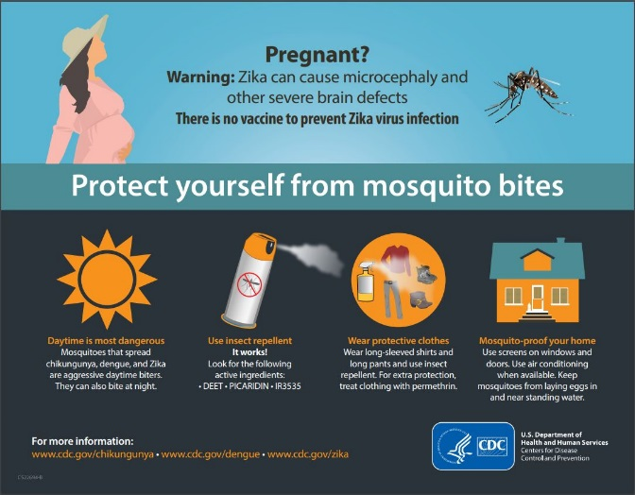
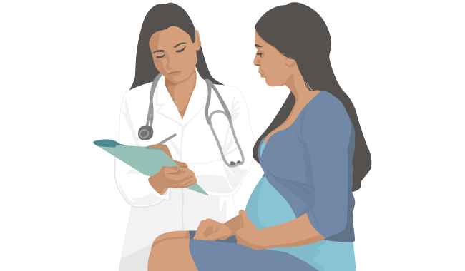

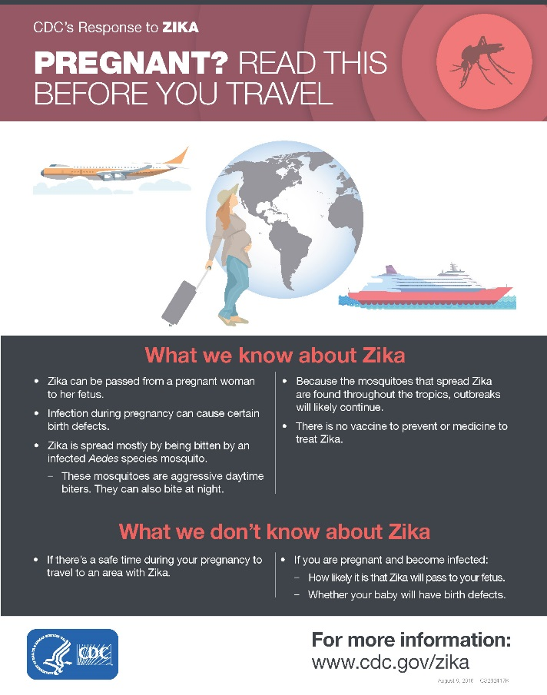
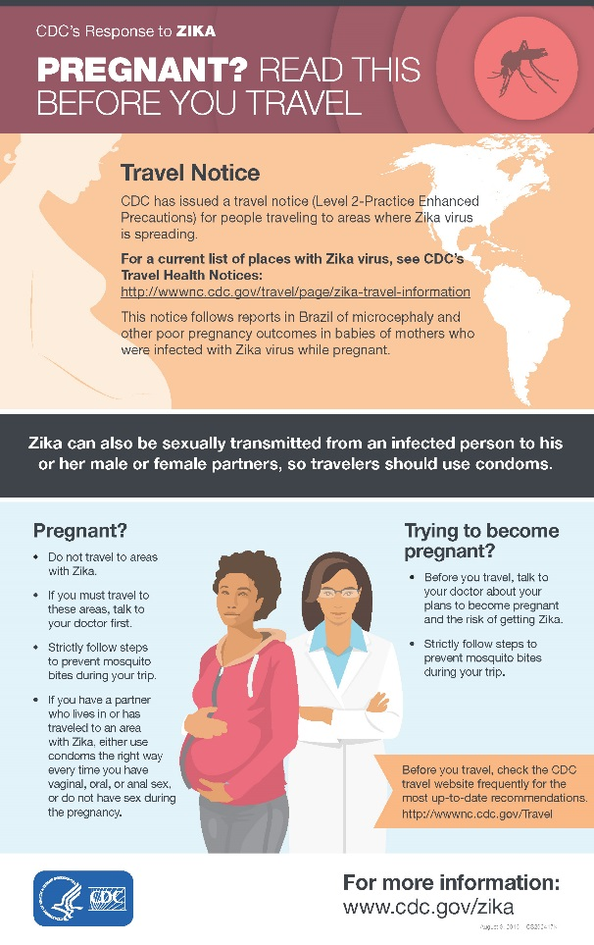

Graphics

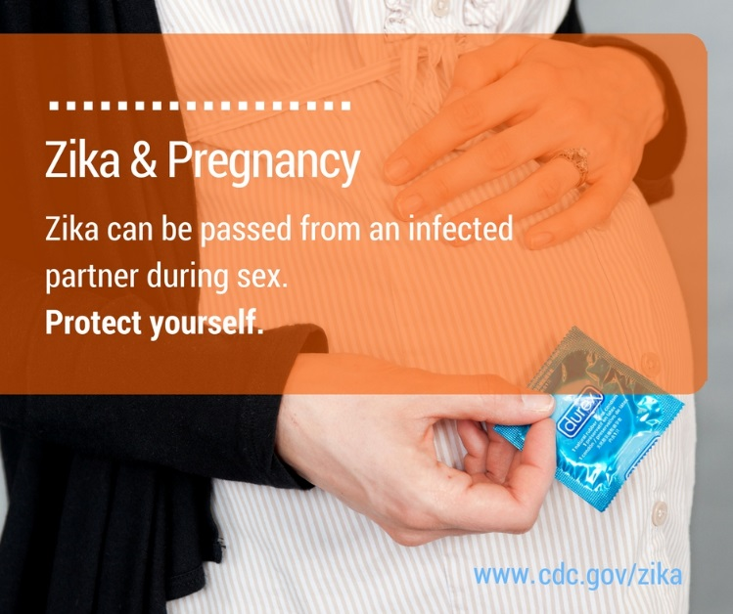
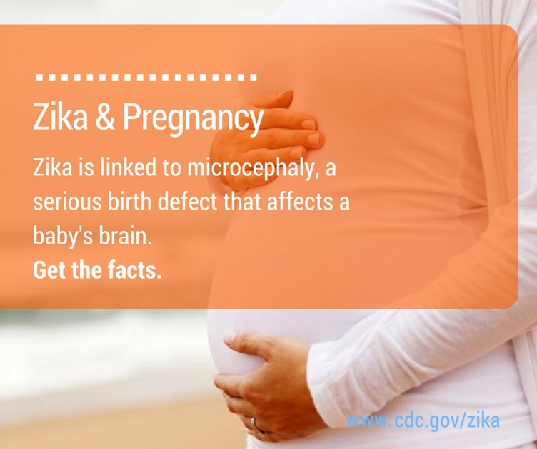

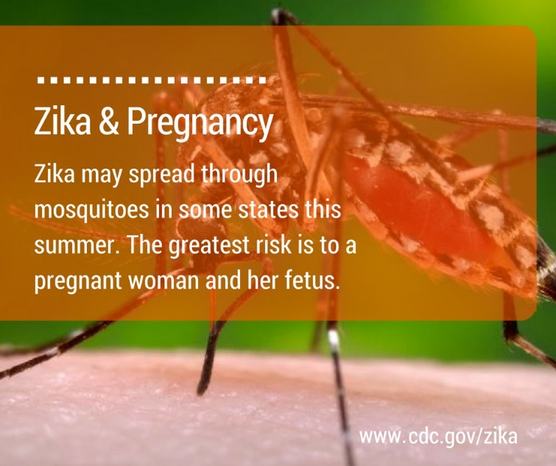
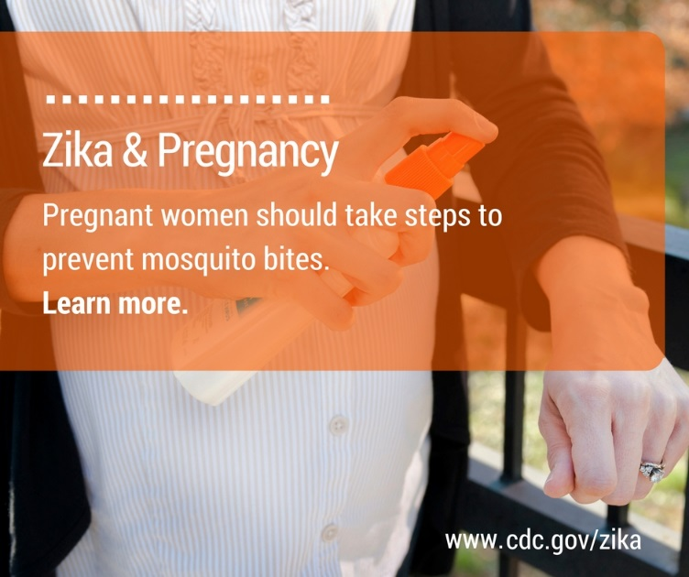

Resource List

CDC Webpages & Materials for Consumers

- Zika Prevention
- Zika & Pregnancy
  - Zika & Pregnancy: How to Protect Yourself
  - Zika & Pregnancy podcast
- Zika and Sexual Transmission
  - Condom Effectiveness
  - How-To Fact Sheet
- Zika communication resources, including fact sheets and posters:
  - Pregnant women considering travel to an area with Zika (poster)
  - For pregnant women in areas with Zika: Protect your pregnancy (poster)
  - Zika and Sex: Information for pregnant women living in areas with Zika (poster)
  - Zika and Sex: Information for men who have pregnant partners and live in or recently visited an area with Zika (poster)
  - Zika and Sexual Transmission: For People Whose Partner Traveled to an Area with Zika (poster)
  - Zika and Sexual Transmission: For People Living in an Area with Zika (poster)
  - Condom Use Palm Card
  - How to Protect against Mosquito Bites (fact sheet)
  - Mosquito Bite Prevention (United States) (fact sheet)
  - Protect Yourself from Mosquito Bites (fact sheet)
  - Protecting Children from Mosquito Bites at Camp (fact sheet)
  - Thinking about having a baby?: Plan Your Pregnancy (fact sheet)
- CDC Vital Signs – Zika and Pregnancy

Resources for Health Departments and Healthcare Providers

- Zika Resources for Healthcare Providers
- Zika Communication Toolkits
- US Zika Pregnancy Registry
- Information for State & Local Health Departments
- Questions and Answers for Healthcare Providers Caring for Pregnant Women and Women of Reproductive Age with Possible Zika Virus Exposure
- Questions and Answers for Healthcare Providers on Sexual Transmission of Zika Virus
- Zika Virus Microsite: Allows you to embed CDC’s Zika content into your own website to easily share information and stay up-to-date with developments on the current Zika virus outbreak.
- CDC Zika Key Messages (updated online weekly)
- Zika Action Planning (ZAP) Summit Follow-up Teleconferences
- Clinical Outreach and Communication Activity (COCA) Zika Resources
  - Clinicians can sign up to receive COCA email notifications about current health issues and emerging threats, including upcoming calls and webinars on emergency preparedness and response topics.

Guidelines and Publications

- Oduyebo et al. Update: Interim Guidance for Health Care Providers Caring for Pregnant Women with Possible Zika Virus Exposure — United States, July 2016. MMWR. 2016 July 29;65(29):739-744.
- Brooks et al. Update: Interim Guidance for Prevention of Sexual Transmission of Zika Virus — United States, July 2016. MMWR. 2016 July 29;65(29):745-747.
- Rabe et al. Interim Guidance for Interpretation of Zika Virus Antibody Test Results. MMWR. 2016 June 3;65(21).
- Simeone et al. Possible Zika Virus Infection among Pregnant Women — United States and Territories. MMWR. 2016 May 27;65(20):514–519.
- Dasgupta et al. Patterns in Zika Virus Testing and Infection, by Report of Symptoms and Pregnancy Status — United States, January 3–March 5, 2016. MMWR. 2016 Apr 22;65(15):395–399.
- Petersen et al. Update: Interim Guidance for Healthcare Providers Caring for Women of Reproductive Age with Possible Zika Virus Exposure—United States, 2016. MMWR. 2016 April 1;65(1):315-322.
- Tepper et al. Estimating Contraceptive Needs and Increasing Access to Contraception in Response to the Zika Virus Disease Outbreak — Puerto Rico, 2016. MMWR. 2016 April 1;65(12):311–314.
- Oster et al. Update: Interim Guidance for Prevention of Sexual Transmission of Zika Virus—United States, 2016. MMWR. 2016 April 1;65(12):323-325.
- Fleming-Dutra et al. Update: Interim Guidelines for Health Care Providers Caring for Infants and Children with Possible Zika Virus Infection– United States, February 2016. MMWR. 2016 Feb 26;65(7):182-187.

