Meet Mary Frances Yeilding of South Highland Church
PC(USA) Young Adult Volunteer for 2017-2018

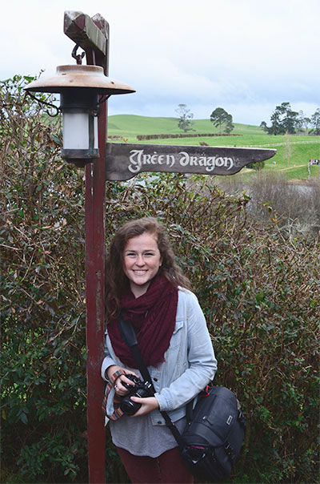
My name is Mary Frances Yeilding. I grew up in Birmingham attending South Highland Presbyterian Church. I am a recent graduate from the University of Mississippi where a received a B.S. in Exercise Science. After my YAV year, I plan on going to grad school for Occupational Therapy. During my time at Ole Miss I was involved in UKirk Campus Ministries, a sorority, a DJ for the campus radio station, a board member for our Dance Marathon, and an intern for Thacker Mountain Radio Show in Oxford. I love playing tennis, hiking, and doing photography in my free time.

About YAV in Boston
In August I will begin my YAV year in Boston! Young Adult Volunteers is a year of service focusing on service to the community, simple living, intentional community, and vocational discernment. There are sites all over the country and a few around the world.

This particular site focuses on food justice--they often refer to this site as The Boston Food Justice Young Adult Volunteer (BFJYAV) program. I will be working with Fourth Presbyterian Church in south Boston and my fellow BFJYAVs will have other job sites around the city. I'm looking forward to this next adventure giving back through the PC(USA) that has given me so much already.

To Support Mary Frances
A link to my YAV bio: https://www.presbyterianmission.org/ministries/yav/yav-new/mary-yeilding/

A link to my blog that I will be keeping throughout the year: https://maryfrancesyav.wordpress.com/

Support in anyway would be greatly appreciated whether it be by prayer or monetarily or both!

Financial support: checks can be made out to the Presbytery of Boston with "Mary Frances Yeilding--BFJYAV" in the memo line and mailed to P.O. Box 760833, Melrose, MA, 02176

