EFFECTIVE 4/3/17
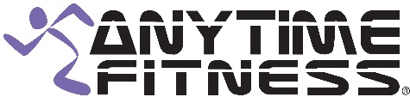 CLASS SCHEDULE
TIME | MONDAY | TUESDAY | WEDNESDAY | THURSDAY | FRIDAY
9:00 AM |  |  | ZUMBA  Nancy Taylor
10:00 AM | GET YOUR  STRETCH ON  Leah Marino | ROCK YOUR BODY  Leah Marino |  | BODY SCULPT  Leah Marino | GET YOUR STRETCH ON  Leah Marino
5:45 PM |  | SPIN/CORE  Dre Hernandez

CLASS DESCRIPTIONS

Zumba: Latin and international music with a fun and effective workout system.
Get Your Stretch On: Warm-up followed by a deep stretch.
Rock Your Body: Cardio based incorporating free weights.
Body Sculpt: Combination of spin, step, bosu, and weights.
Spin/Core: This 30 minute Spin plus 15 minute core class is designed for low impact intervals to get your heart rate pumping mixed with Core training. 45 minute class.

