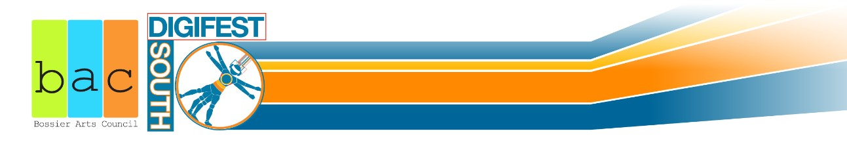
Bossier Arts Council
Digital Art Competition Application
(PLEASE NOTE: ALL REQUESTED INFORMATION MUST BE PROVIDED OR THE APPLICATION WILL BE REJECTED)
PLEASE FILL OUT A SEPARATE APPLICATION FOR EACH SUBMISSION-
THERE IS A $10.00 SUBMISSION FEE PER ENTRY. ALL FEES MUST BE SUBMITTED WITH THE APPLICATION.
(Student/Military entry fees will be waived. Must provide valid ID).
Artist Name: Mailing Address: City, State, Zip: Phone Number: Email: Artwork Title: Medium:
- Digital Photography
- Graphics (3D renderings, Illustrations, Photoshop, Web Design, Logos, Advertisements, Posters, etc.)
- Digital Lagniappe (Digital Music, Video, Animation, Interactive)
**All submissions must be five minutes or less in duration.

*All artworks must be original. Please note that the BAC reserves the right to refuse any submission for any reason at any time. Please be aware that this event is an Education Initiative of the BAC and therefore students will be in attendance. Please direct questions to Alex Stinchcomb (Community Development Coordinator) at alex@bossierarts.org.
Submission fee of $10.00 must be included with each application. (Fee is waived for students and military. Must provide valid form of ID with application)
All applications, entry fees, & artworks must be received by Wednesday, September 27th, 2017 by 4 pm to the Bossier Arts Council.

DigiFest South 2017
C/O Bossier Arts Council/ Alex Stinchcomb 630 Barksdale Blvd.
Bossier City, LA 71111-4412

Applicant Signature Date

