Divide County Challenges
Like other counties, Divide County is going out of 2016 with less oil activity, but unlike other counties, 2017 will present at least one unique radioactive oil field challenge.
The 2017 challenge unique to the Divide County is at Noonan. Divide County Commissioner Gerald Brady said one abandoned lot there has higher-than-safe radioactivity. It’s where an abandoned stash of tenorm radioactive socks were discovered in an empty building in 2015. The county got the building when several years of taxes went unpaid. Now it’s up to the county to do something with the building and the lot. The state cleaned up the stash of radioactive socks, but enough radioactivity remains in the building and the ground that the lot cannot be occupied. 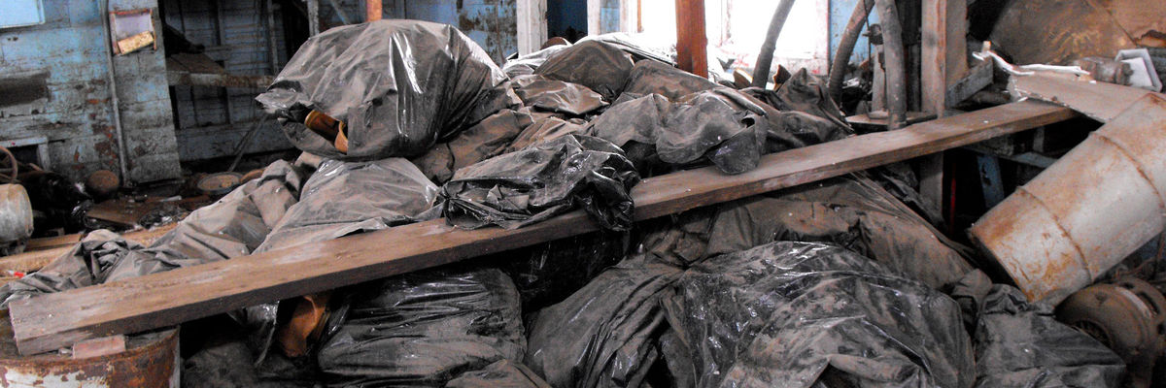
The Williston Herald photograph shows the pile of radioactive wasted that was discovered in the abandoned building.
Brady said the county got the building back in October, and now it’s looking for help from the state or other sources. “We have to decide what is to be done, and who can help,” he said. The soil and building material has been measured to have “higher radioactivity than any landfill in the state will accept.”
Roads -- Brady said this week that like the rest of the region, Divide County is busting through snow drifts across the road while battling sub-zero temps. The County has a full time road crew and it’s putting in over time this month clearing not only county roads, but township roads. He said the hectic pace of oil activity and traffic on the county’s road has diminished. In recent months, only one or sometimes two drilling rigs have been operating in the county. He said, however, there are several dozen wells drilled waiting to be fracked, so he anticipates activity will be constant, just not hectic. He said the roads are in in “not too bad of shape.” In 2017, a 3-mile section of County Road 2 extending from Highway 85 will be rebuilt, but that job has not yet been bid.
Courthouse -- In a few days, the addition to the Courthouse will be closed in, windows will be installed, and work will continue through the winter. The addition is to be completed in May with some remodeling of the existing courthouse to be complete by August. That’s when the county will celebrate the 100th birthday of the courthouse in August, right after the annual Threshing Bee in Crosby.

