Theo Owens from 2016 to present
Theo Owens - 17U Head Coach
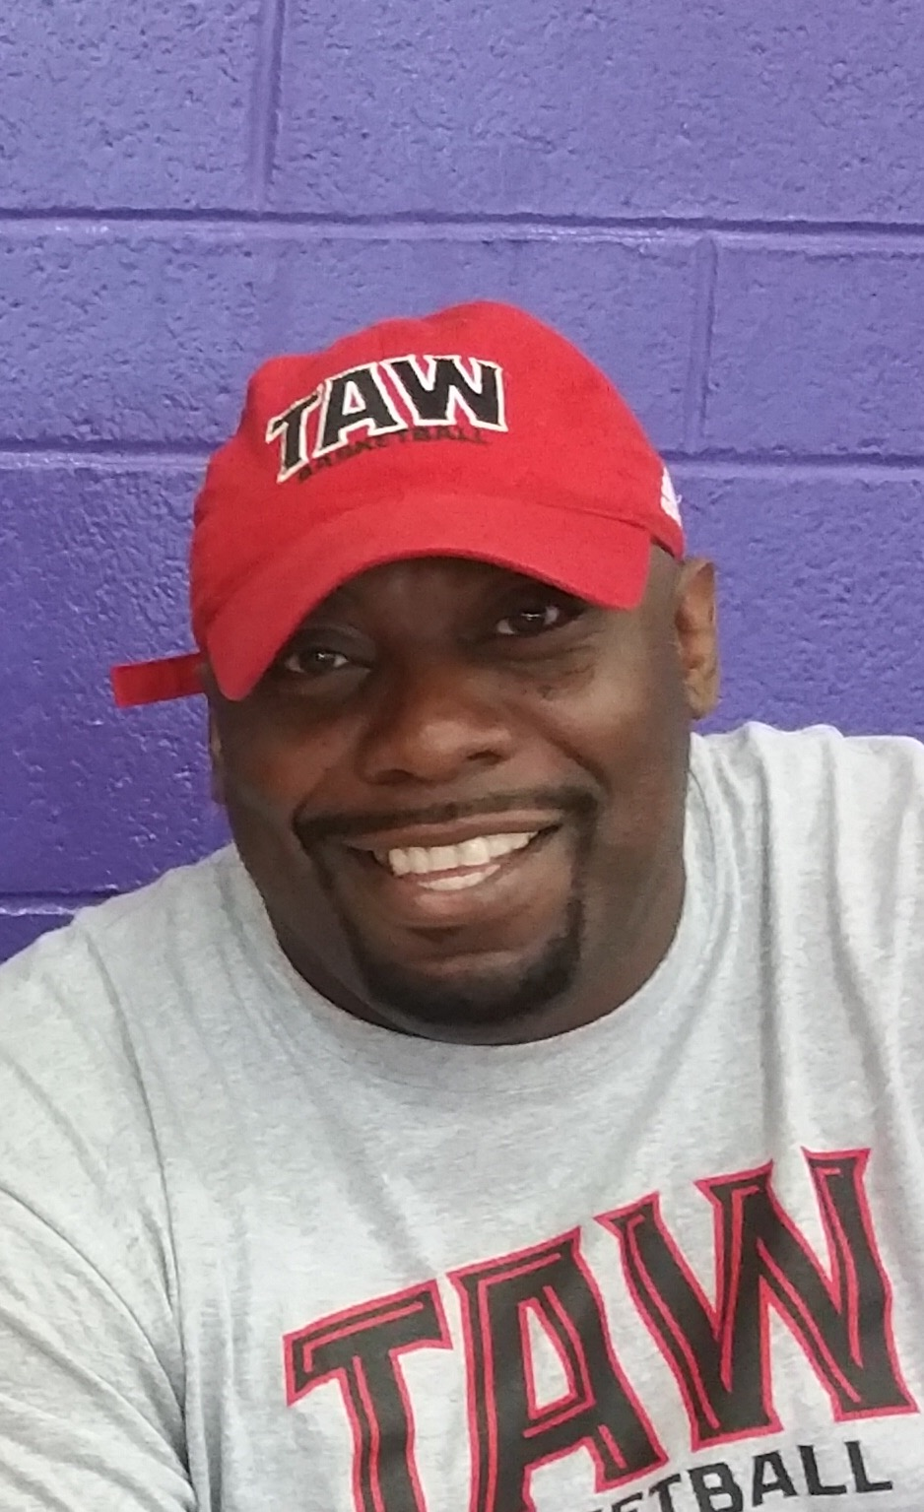
Coach Theo Owens is more than a basketball instructor. He is passionate about serving and mentoring his players while cultivating a conquering intellect that will not be negotiated nor intimidated.

Coach Owens is serving his second season at TAW as head coach of the 17U boys basketball team. In 2016, his team finished 11-3 on the Adidas Gauntlet Silver circuit with an overall record of 43-10. He lead his team to the Gold/Silver bracket championship where they competed in 4 out of the 8 tournaments and advancing to the Elite 8, where they competed in 6 out of the 8 tournaments.

Prior to TAW, Coach Owens completed 5 seasons serving at the perennial powerhouse Proviso East High School as an Assistant Coach of the Varsity Boys Basketball Team. For the past 3 years, he has served as the Head Sophomore Boys Basketball Coach with an overall record of 65-9.

While serving at Proviso East, Coach Owens has helped lead them to 2 Final Four appearances, 1 State Finals, 3 Regional Championships, 2 Sectional Championships and 2 Super-Sectional Championships. He has assisted in placing over 20 players to the collegiate level including, Branden Jenkins (LSU), Jevon Carter (West Virginia), Keith Carter (St. Louis/Valparaiso), Kalin Fisher (Hampton), Paris Lee (Illinois State), Gabe Levin (Long Beach State), Sterling Brown (SMU), Paris Burns (UIC), William Gates Jr (Furman/Houston Baptist), Malachi Nix (Fairleigh Dickerson), just to name a few.

Coach Owens motto is “You Get Out Of This What You Put In It”.

